**VOIP Part 2 (Customized Ringtone, Call In & Out, Voicemail)**

Juntao Zhong

ccnp (cisco certified network professional)

feb. 2019

NEWPORT HIGH SCHOOL, WA

## Purpose

The purpose of this lab is to configure **CUCM (Cisco Unified Communication Manager)** to implement **Call In & Call Out** to outside numbers through **PSTN (Public Switched Telephone Network)**, and to customize **Ringtone** & **Music on Hold**. In addition to some CUCM configuration, I also setup a **CUC (Cisco Unity Connection)** server to enable **Voicemail**.

## Backgroud:

Call in & Call out, Ringtone & Music on Hold (HOD) are functions in CUCM. Ringtone and HOD is based on CUCM’s TFTP server to its phones. To edit the TFTP server in CUCM, we need to the TFTP server in our PC, too.

PSTN line can look exactly like Ethernet line. Voice ports also look like Ethernet ports, but just a little smaller. PSTN is not compatible with the Ethernet, because PSTN is analog, rather than digital. A converter between PSTN and Ethernet is necessary in this lab.

Voicemail requires both CUCM and CUC. These are software (app) level configuration. The voicemail server has a directory number like the phones; phones also have a separated number for voicemail (one number for calling and one for voicemail). And whenever you need to hear voicemail, your phone dial that specific number for the centralized service from CUCM and CUC server.

## Lab summary

First, I made the “mp3.” file music into the right format. “wav.” for Music on Hold and “raw.” for Ringtone. All music upload is through the CUCM GUI. MOD configured through the CUCM GUI. Ringtone customization needs both TFTP server on PC and CUCM GUI.

Then, I configure the voice gateway (a router that have both voice (PSTN analog) and ethernet ports). PSTN comes with a pre-fix in the beginning of the numbers. For example, in my lab, the pre-fix is (425)-456-XXXX, I configure the last four numbers on my phone (my local phone’s number is 3333). Some configuration on CUCM is required.

For voicemail, I need to install another server that runs CUC. Two servers will be communicating with each other. CUCM will act as the administration server and CUC will store the voicemail files. Configuration on both CUCM and CUC is necessary for voicemail to run. After the voicemail is set up, you need to go into your phone, press “Message” button on your phone. Then, set up your personal voicemail/password before using voicemail.

## Lab Diagram

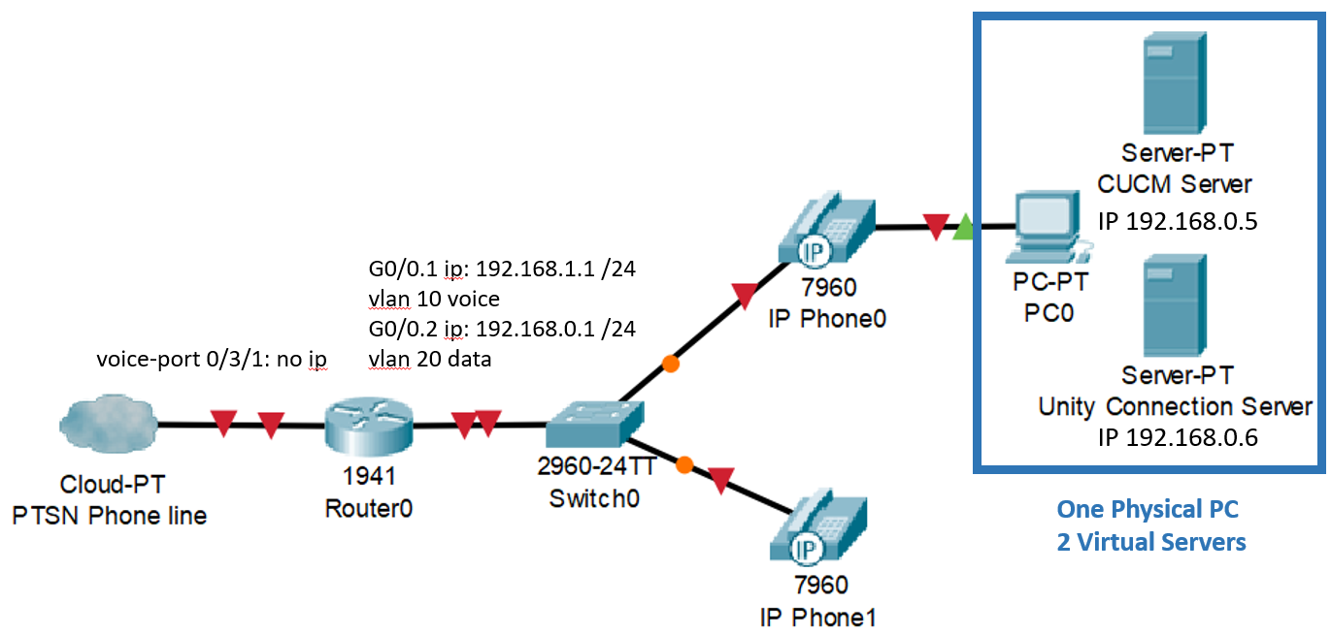

## Lab commands

### Dial-in Commands:

voice service voip

Allow-connections h323 to h323 (setup H323 connections)

voice-port 0/3/1 (enter the voice port to configure it)

dial-peer voice 10 voip (define voip vlan)

dial-peer voice 1 pots (define the destination patter for calling out)

mgcp call-agent 192.168.0.5 service-type mgcp version 0.1 (define CUCM server address)

destination-pattern 9T (define that when user add a “9” before the number, router will route the call out)

direct-inward-dial (allows calls coming PTSN to enter the VOIP lines)

forward-digits 11 (normal phone number is 10 digits, plus a number, in this lab is “9”, that tells the system to call out)

### No router Commands necessary for voicemail or rangtone

## configuration of both servers and routers

### Switch & Voicegateway (Router) configuration:

**Router(config)#** **hostname Voicegateway**

ip dhcp excluded-address 192.168.0.1 192.168.0.10

ip dhcp pool IPpool

network 192.168.0.0 255.255.255.0

default-router 192.168.0.1

option 150 ip 192.168.0.5

ip dhcp pool IPpoolvoice

default-router 192.168.1.1

network 192.168.1.0 255.255.255.0

option 150 ip 192.168.0.5

voice call send-alert

voice rtp send-recv

voice service voip

allow-connection h323 to h323

interface FastEthernet0/0

no shutdown

interface FastEthernet0/0.1

encapsulation dot1Q 10

ip address 192.168.1.1 255.255.255.0

interface FastEthernet0/0.2

encapsulation dot1Q 20

ip address 192.168.0.1 255.255.255.0

voice-port 0/3/1

connection plar opx 3333

caller-id enable

signal groundStart

timing hookflash-out 50

timing guard-out 1000

ccm-manager config server 192.168.0.5

ccm-manager config

mgcp call-agent 192.168.0.5 service-type mgcp version 0.1

mgcp profile default

dial-peer voice 10 voip

destination-pattern 3333

session target ipv4:192.168.0.5

dtmf-relay h245-alphanumeric h245-signal

dial-peer voice 1 pots

destination-pattern 9T

direct-inward-dial

port 0/3/1

forward-digits 11

telephony-service

max-ephones 10

max-dn 10

ip source-address 192.168.0.5 port 2001

ntp master 2

ntp update-calendar

ntp server 192.168.0.1

**Switch(config)#** **hostname SW1**

vlan 10

name voice

vlan 20

name data

interface FastEthernet0/1

switchport trunk encapsulation dot1q

switchport mode trunk

interface FastEthernet0/2

switchport access vlan 20

switchport mode access

switchport voice vlan 10

spanning-tree portfast

interface FastEthernet0/3

switchport access vlan 20

switchport mode access

switchport voice vlan 10

spanning-tree portfast

### Serverice activations needed for this lab:

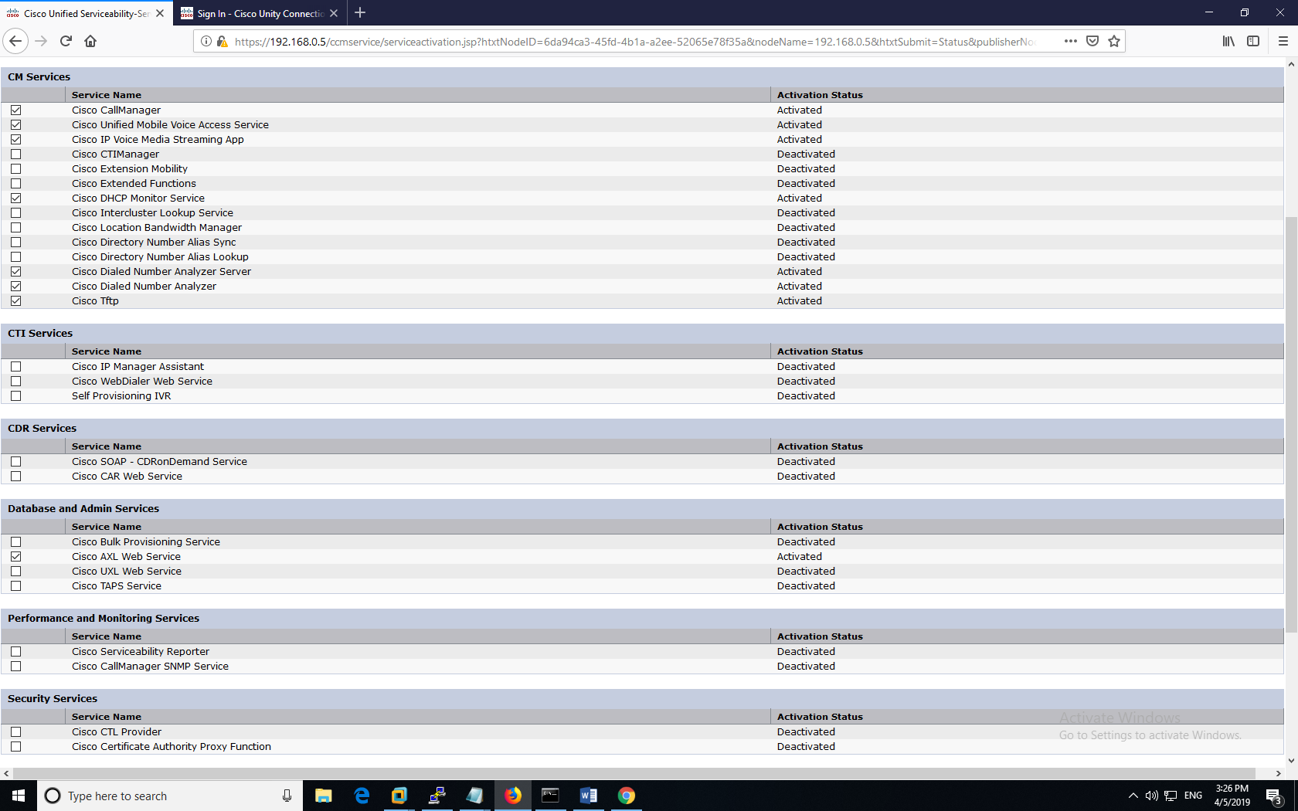

In Cisco Unified Serviceability (you can get to it through the navigation bar)

In Tools=> Service Activation

Activate services in red box.

### Music on hold (hod) configuration:

First, I need to convert the music into the right format (wav.). I download a mp3. music online. Open the mp3. file in Audacity and export it as a wav. file.

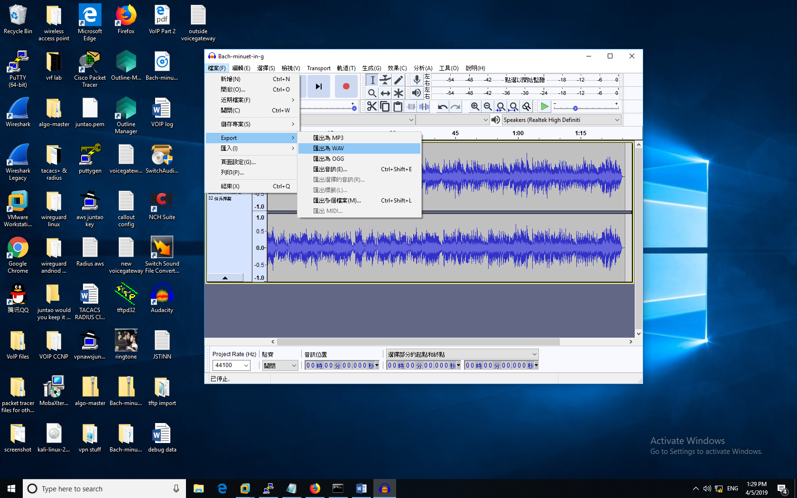

In **Cisco Unified CM Administration => Media Resources => MOH Audio file** **Management**. Then, upload the previous wav. file through the CUCM Web GUI.

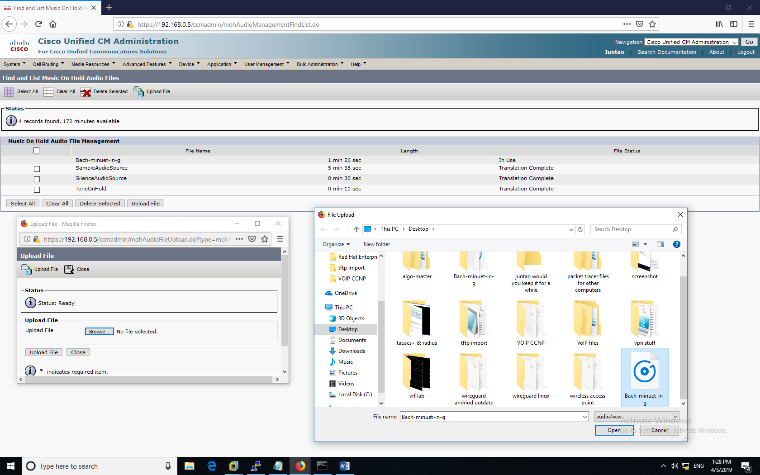

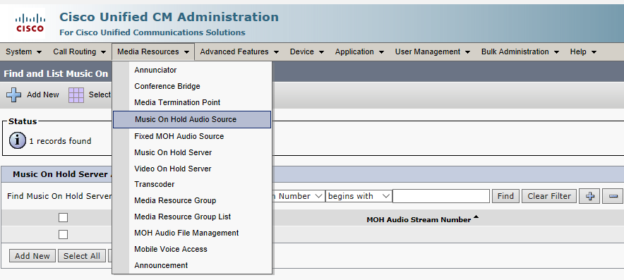

Then, go to “Music on Hold Audio Source” in the similar place. Click the MOH Stream Number 1 (you can add or use other streams, too) to get into the next step (it’s covered by the drop-down). In Stream 1, define the music that you want for MOH (I used a different piece, but it’s the same idea). The audio source name is “Seekers”.

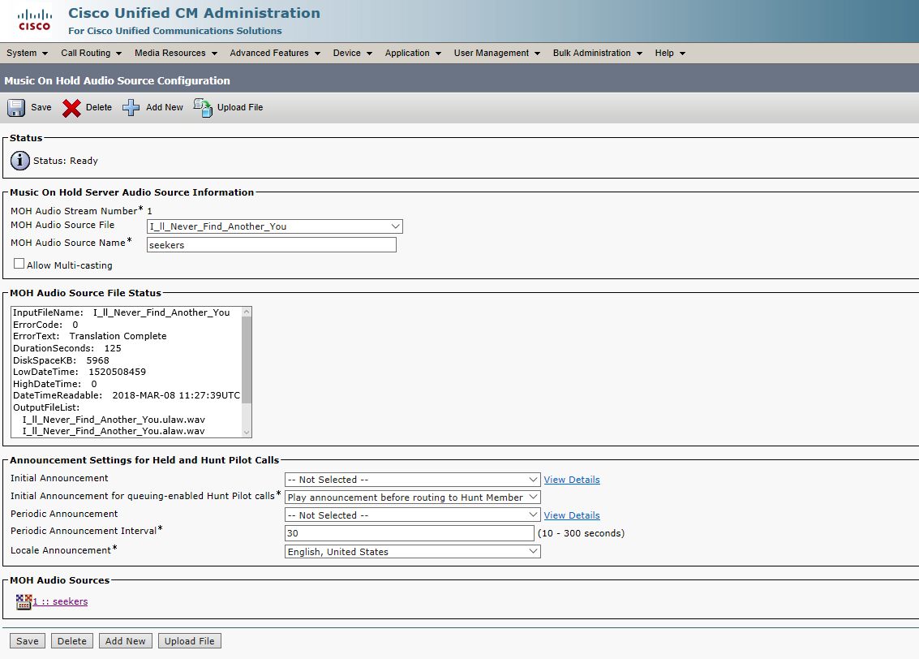

Then, I go into each individual phone through the “device => phone”. Change the MOH into “1-seeker”, which means stream number 1, seeker. Do it for both phones and apply configuration.

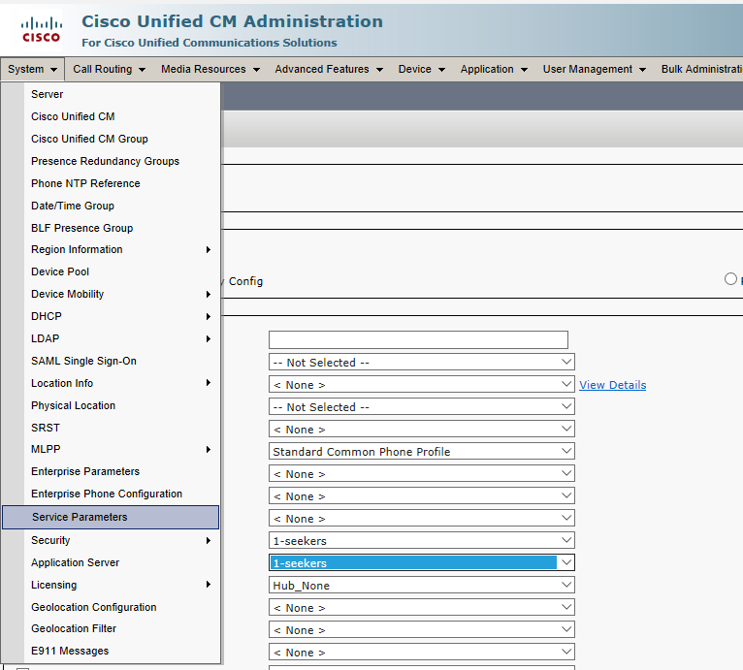

Go to **Bulk Administration => Phones => Query**, to further apply the changes. Click “find” to make two phones to show up. Click the changes in MOH files. And click “submit”.

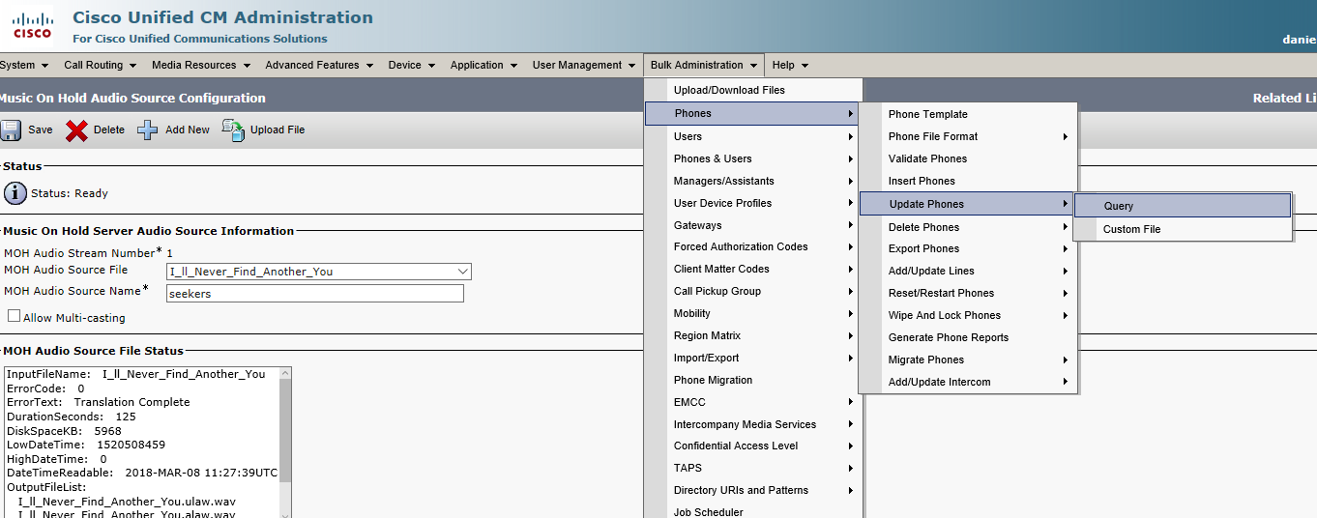

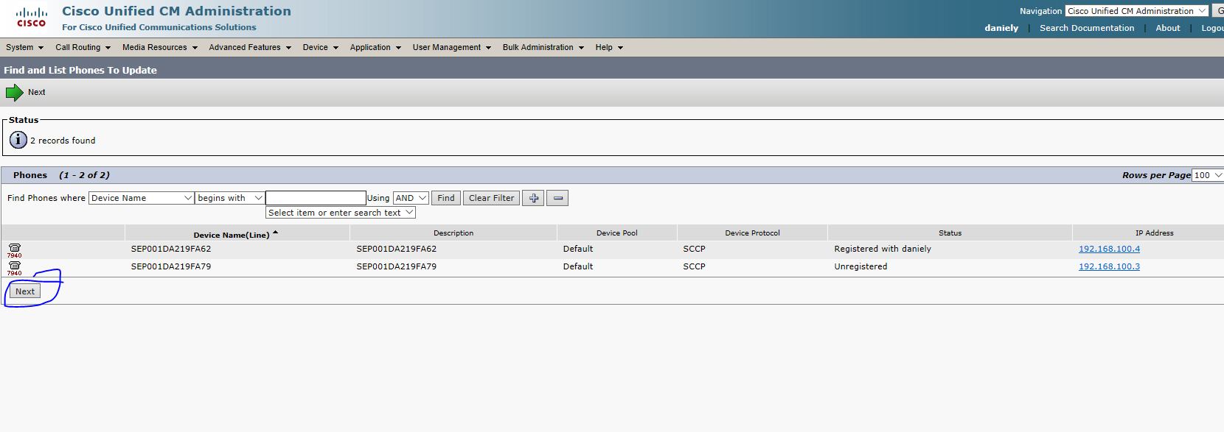

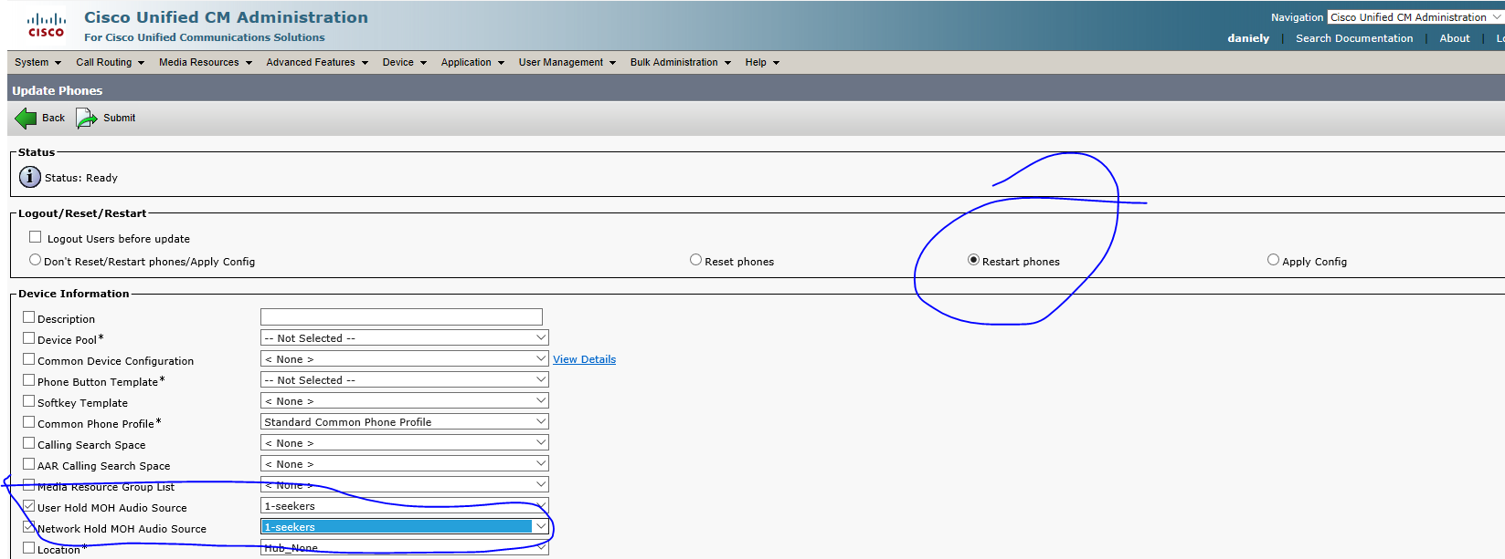

Then, Music on Hold is configured.

### Ringtone customization configuration:

#### **Making the music into the right format (.raw).**

Like MOH, ringtone also need the right music format—“.raw”. Ringtones are usually short (10-15 seconds) and mono-soundtrack.

We first open our mp3. format music in Audacity, and select the short section of music.

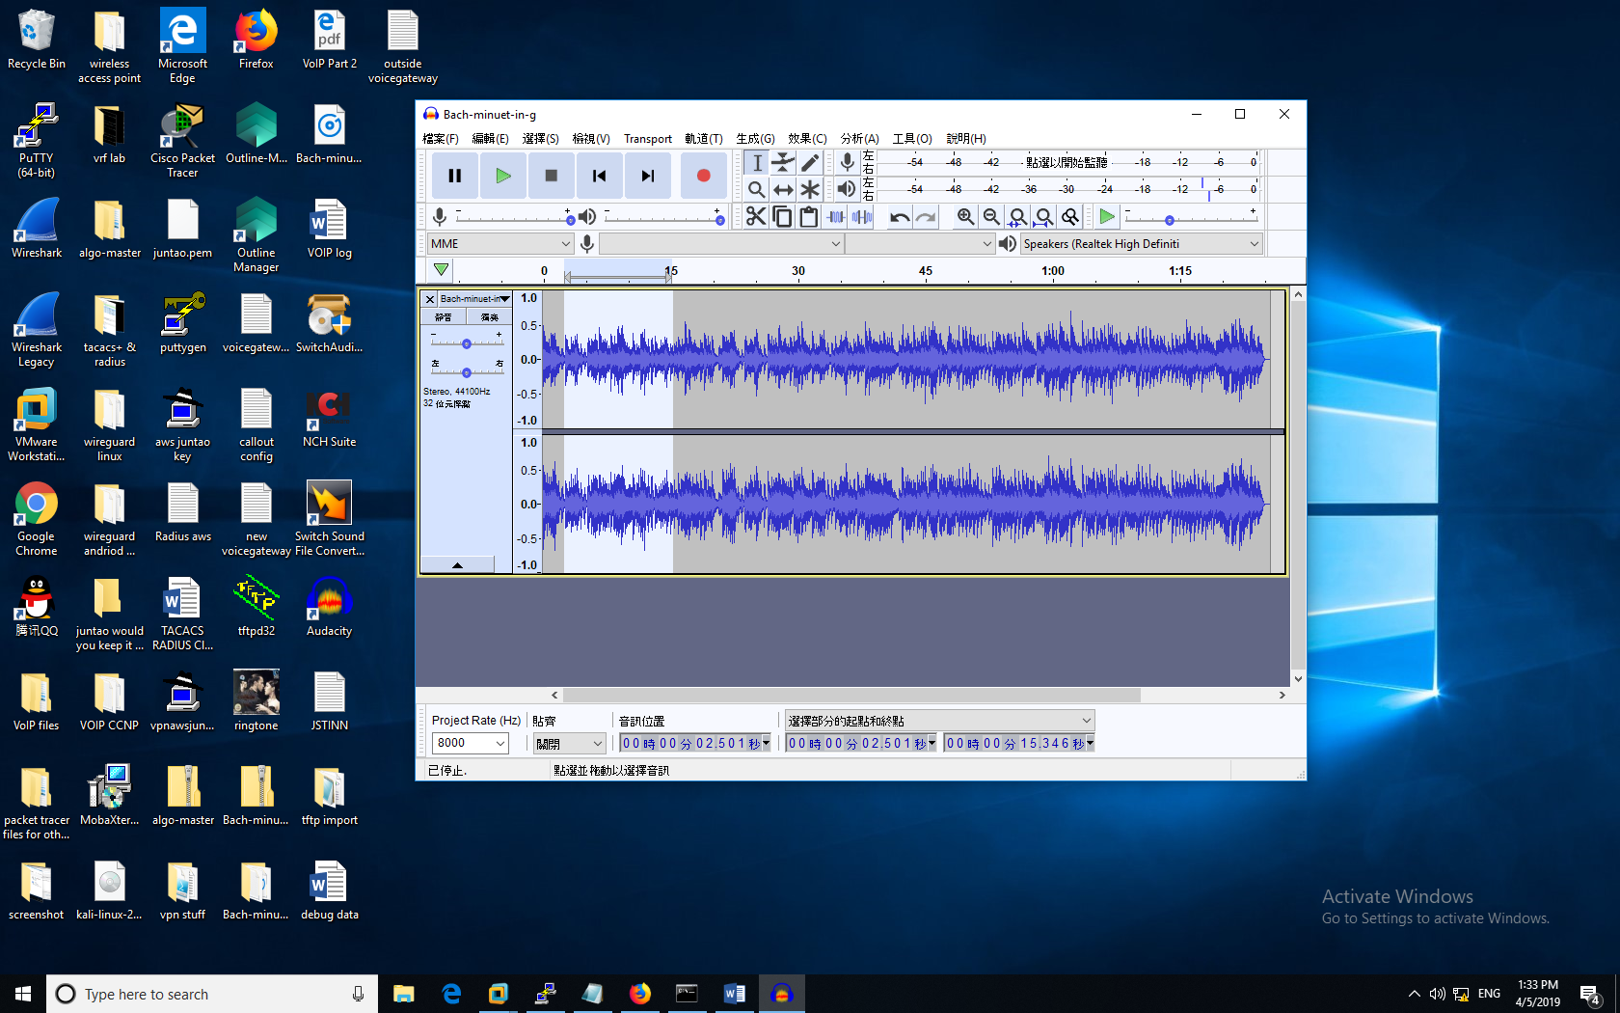

There are two tracks (left and right) at this moment. We want the music to be mono soundtrack. To do that, first, click the triangle on next to the music name. There are several options, and one of them is to have the two tracks separated. (PS: the short music segment was covered by the dropdown).

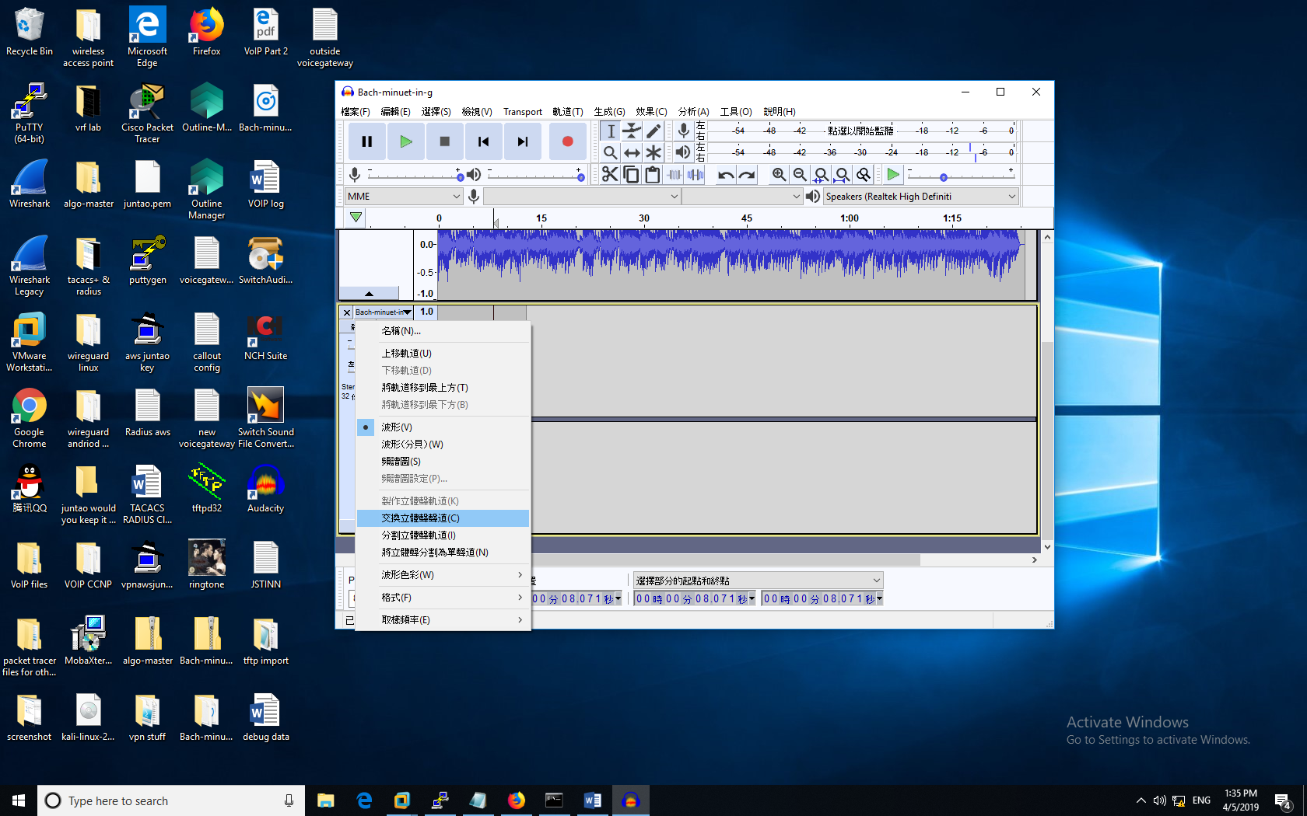

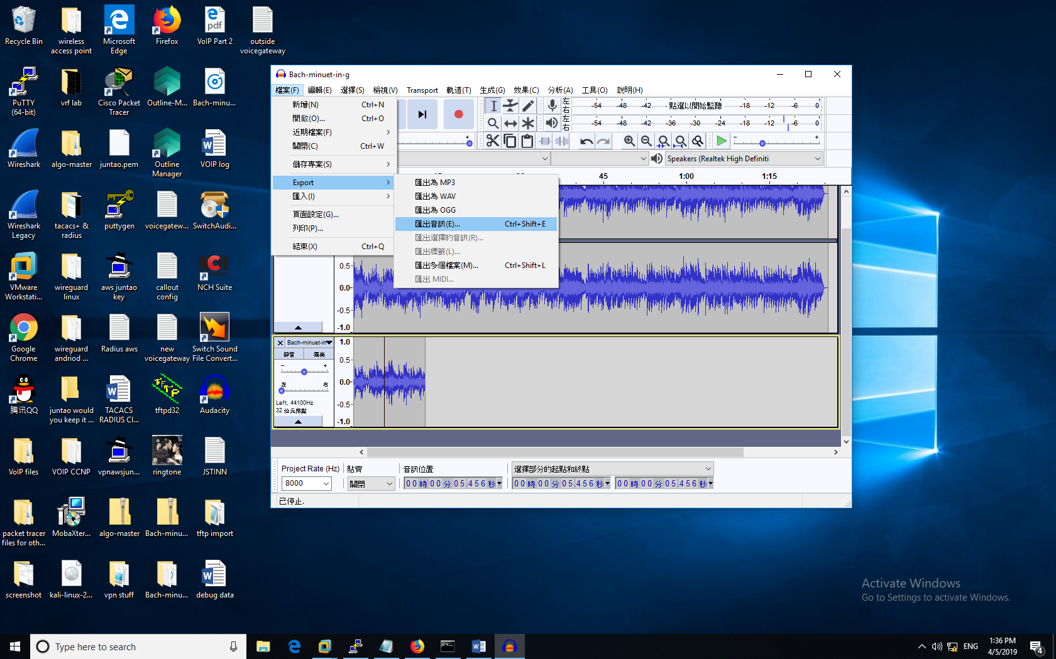

Lower Pic: you will enter this after. Make sure you select “other **uncompressed** file”. And **RAW** format, **U-law** Coded.

Sorry it’s in Chinese

Upper Picture: After separating two tracks, delete one of them and export it as “.raw” file ( .raw option is a little difficult to find).

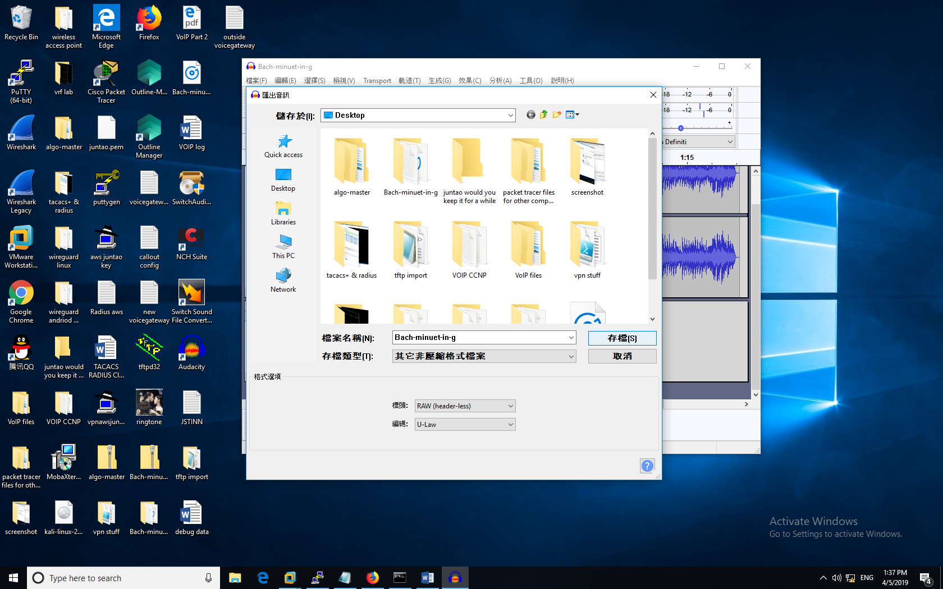

#### **Obtain and edit CUCM’s directory for Ringtone through tftp server:**

Open a Tftpd32 => Tftp Client. The server interface is the IP address of your physical computer (either statically assigned or digitally assigned). The host is your CUCM server. We are looking for two files that controls the ringtone directory in CUCM— “Ringlist.xml” and “Ringlist.dat”

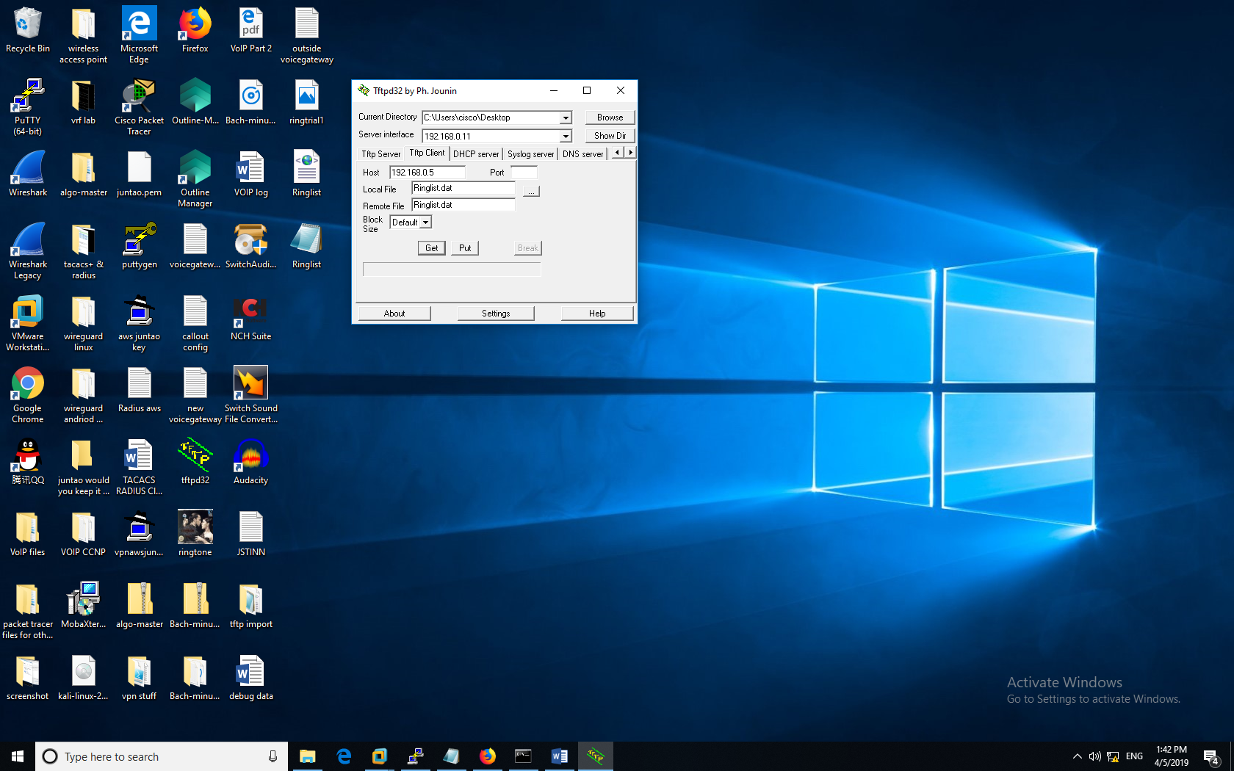

Then, click “get” to request “Ringlist.dat” and “Ringlist.xml” from the CUCM.

In yellow box: the image-looking “ringtrial1” is the “.raw” music file; two different-looking “Ringlist” are the “.dat” and “.xml” file. We will need to edit them separately.

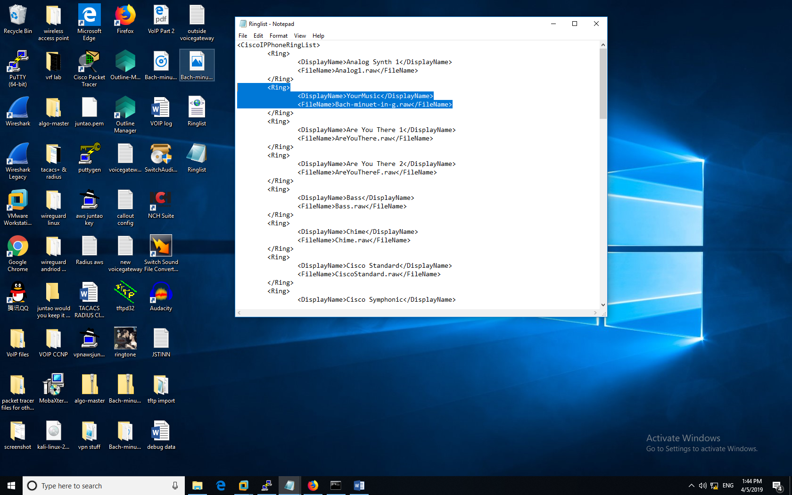

Both Ringlist files are edited in Notepad. Follow the formats of other system-defaults. You can put anything for the “display name” (the music name that you will see on your phone). But make sure that “filename” is exactly the same as your “.raw” music file.

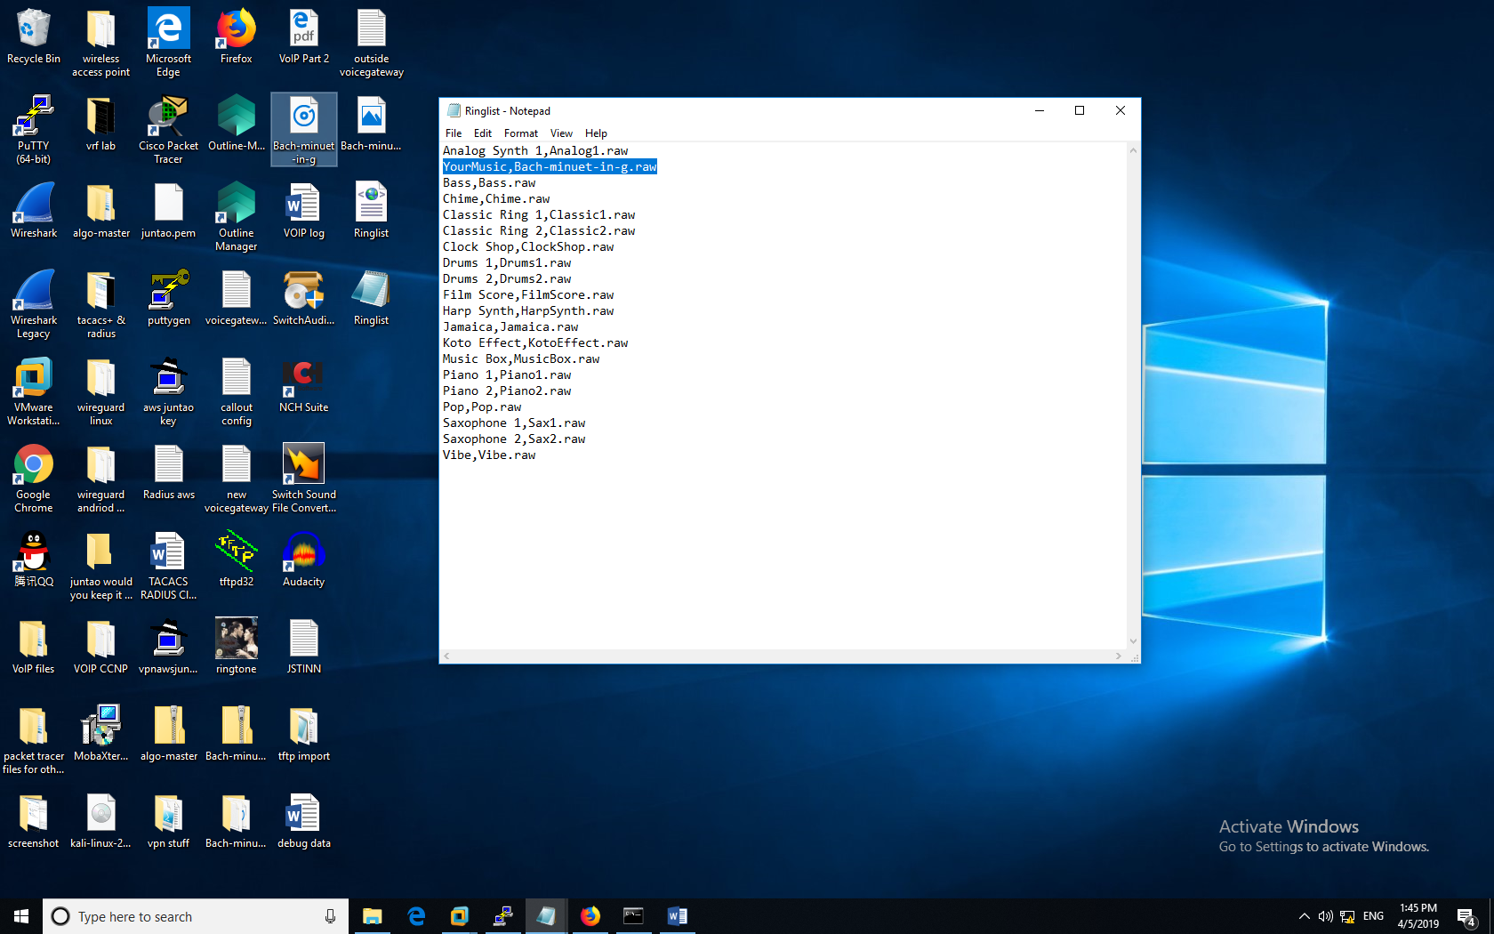

#### **Upload and replace the Ringtone directories and file:**

Then, go to the CUCM Web GUI. Attention! This time we are not going into Cisco Unified UM Communication. Instead, we are going to Cisco Unified Operating System Administration (you switch by clicking the Nav bar on top right).

Click Software Upgrades => TFTP File Management

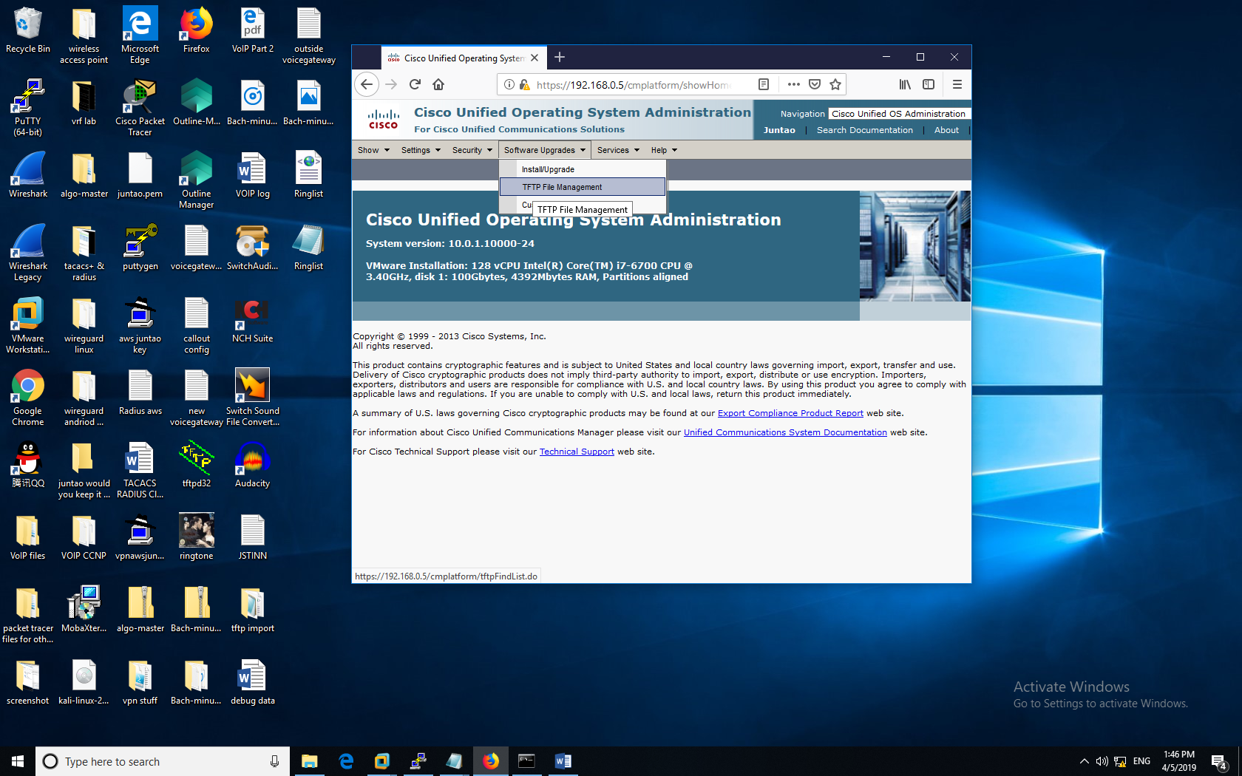

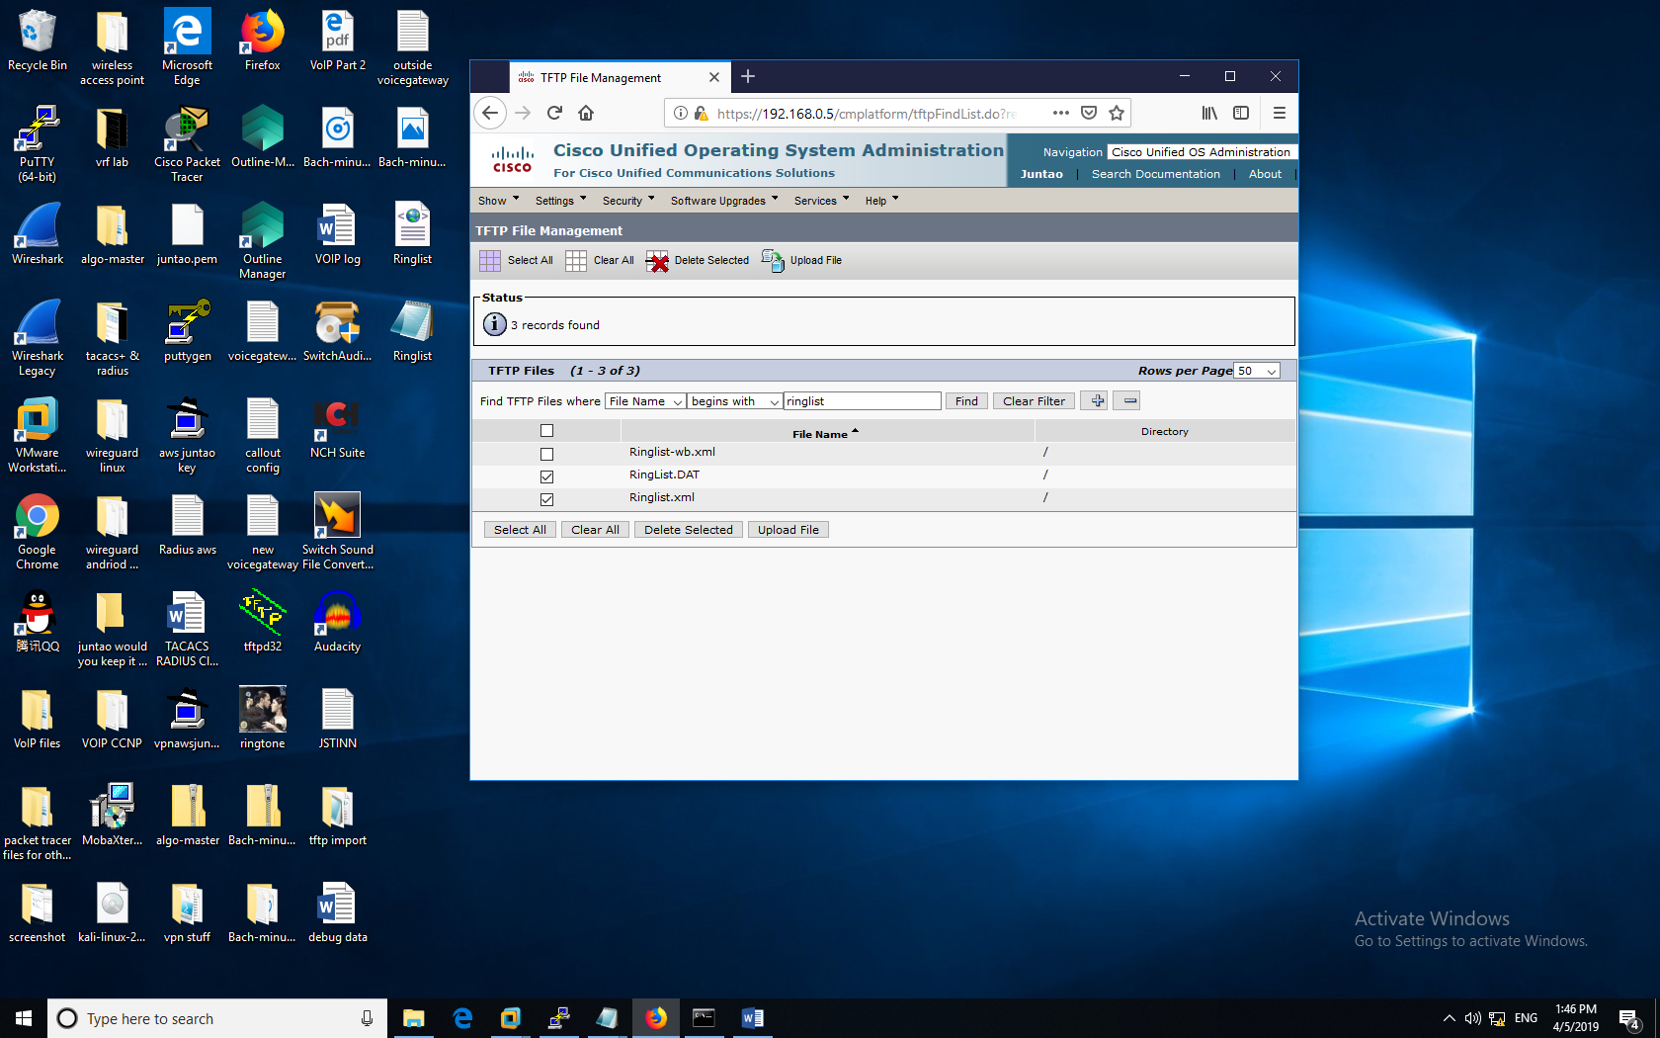

Select the two old directory files (codes) and delete them. We are going to replace it with our new codes.

After deleting them, you will no longer see “Ringlist.dat” or “Ringlists.xml”. To implement your new directory, click “Upload File” (you can use “put” command on the tftp32 server, too). You need to upload 3 files: new “Ringlist.xml”, “Ringlist.dat” and your new “.raw” format ringtone.

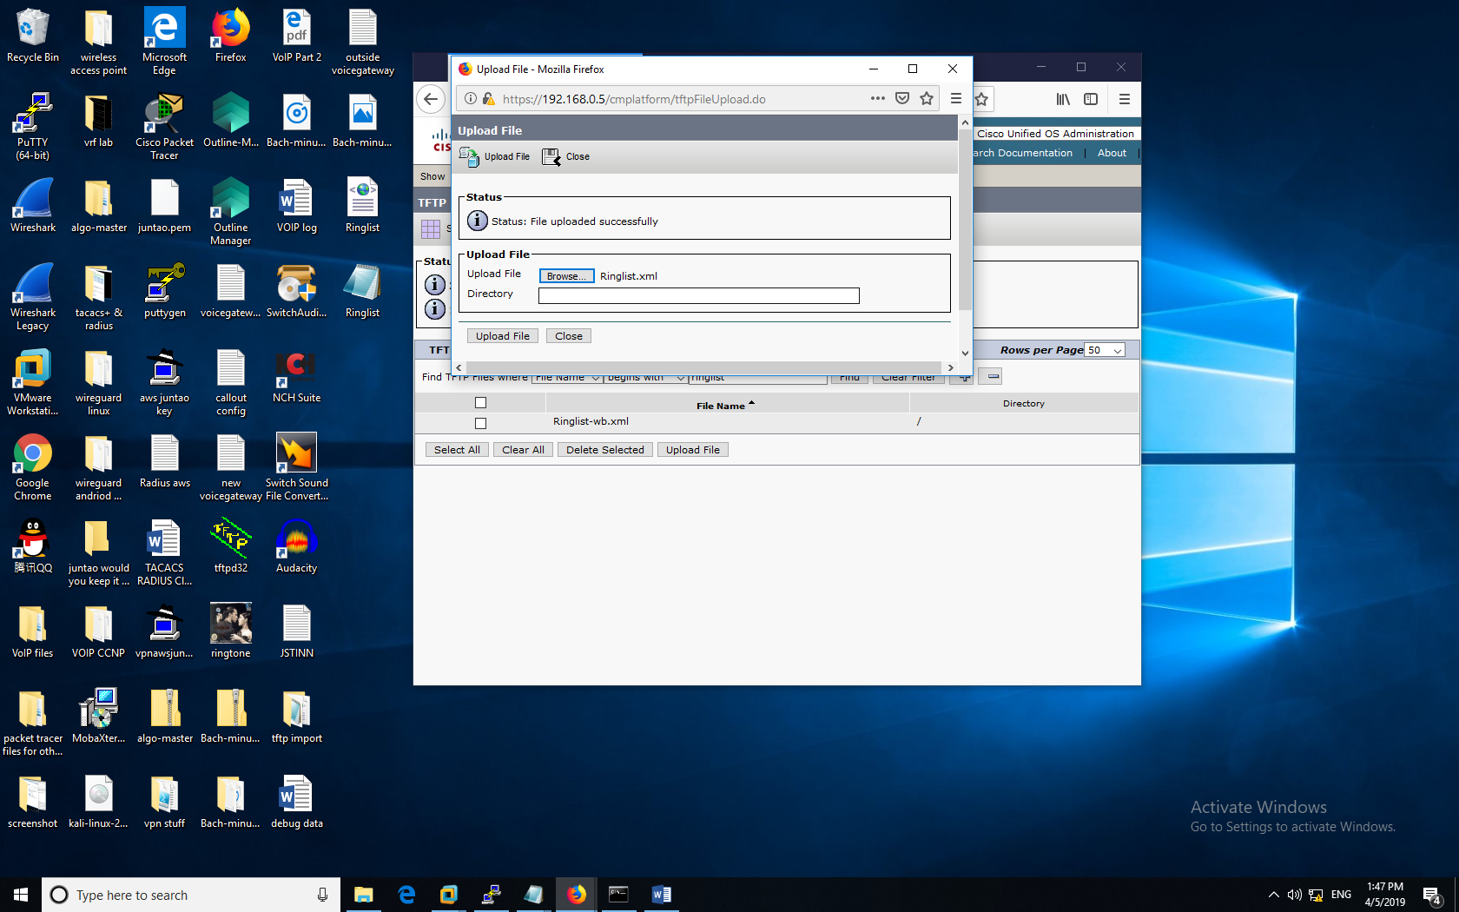

you don’t see the two files you deleted before.

After Uploading, check (search) that your new “.raw” music file, “.dat”, “.xml” files have been successfully added.

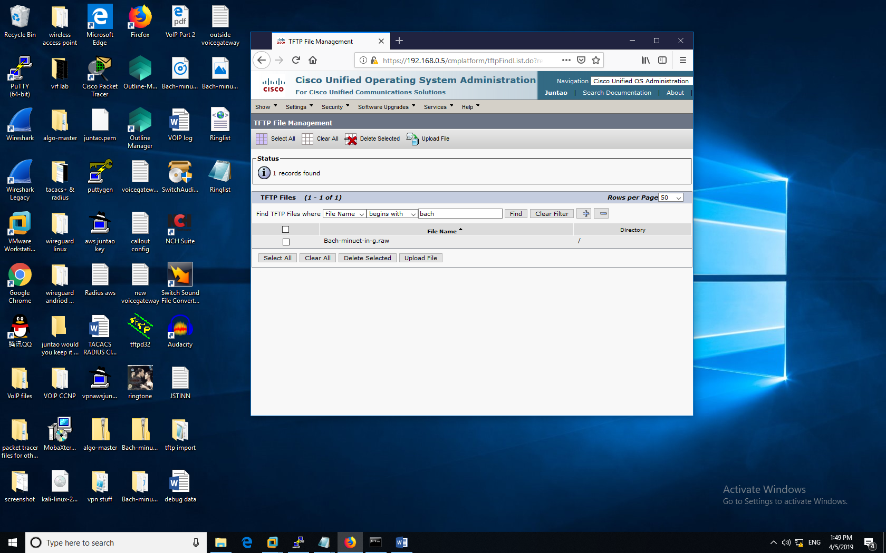

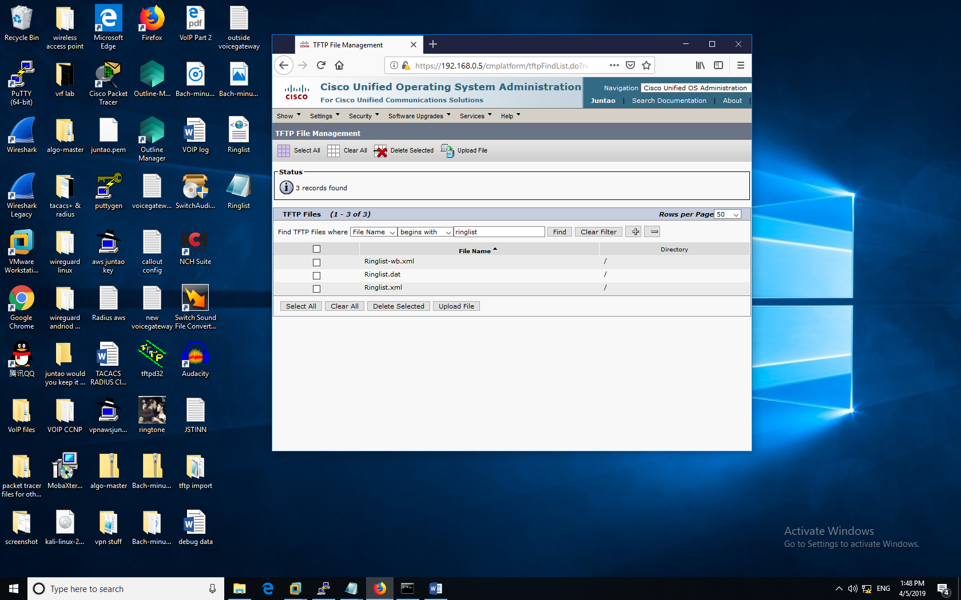

Now, you are almost done. Just need to restart the tftp ringtone service in CUCM. Exit Cisco Unified Operating System Administration and go to **Cisco Unified Serviceability** with the navigation bar

Go to Tools => Control Center- Feature Services

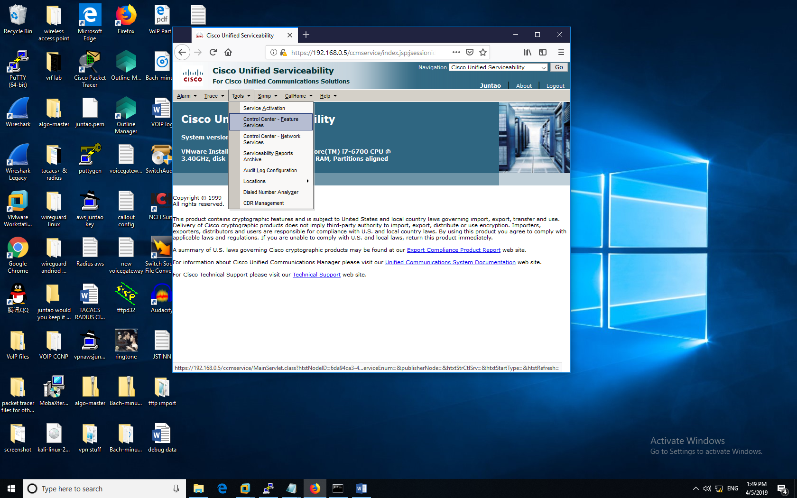

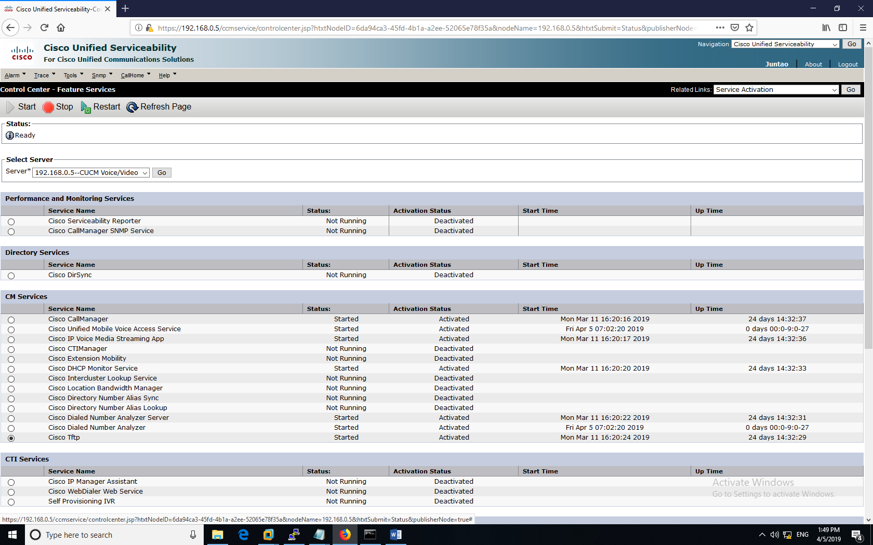

Select Cisco tftp Service. Make sure it’s started and Activated (if not, you can activate it in Tools=> Service Activation in the previous screenshot). Restart it.

Then, go to the setting of your phone. And you choose the ringtone you want.

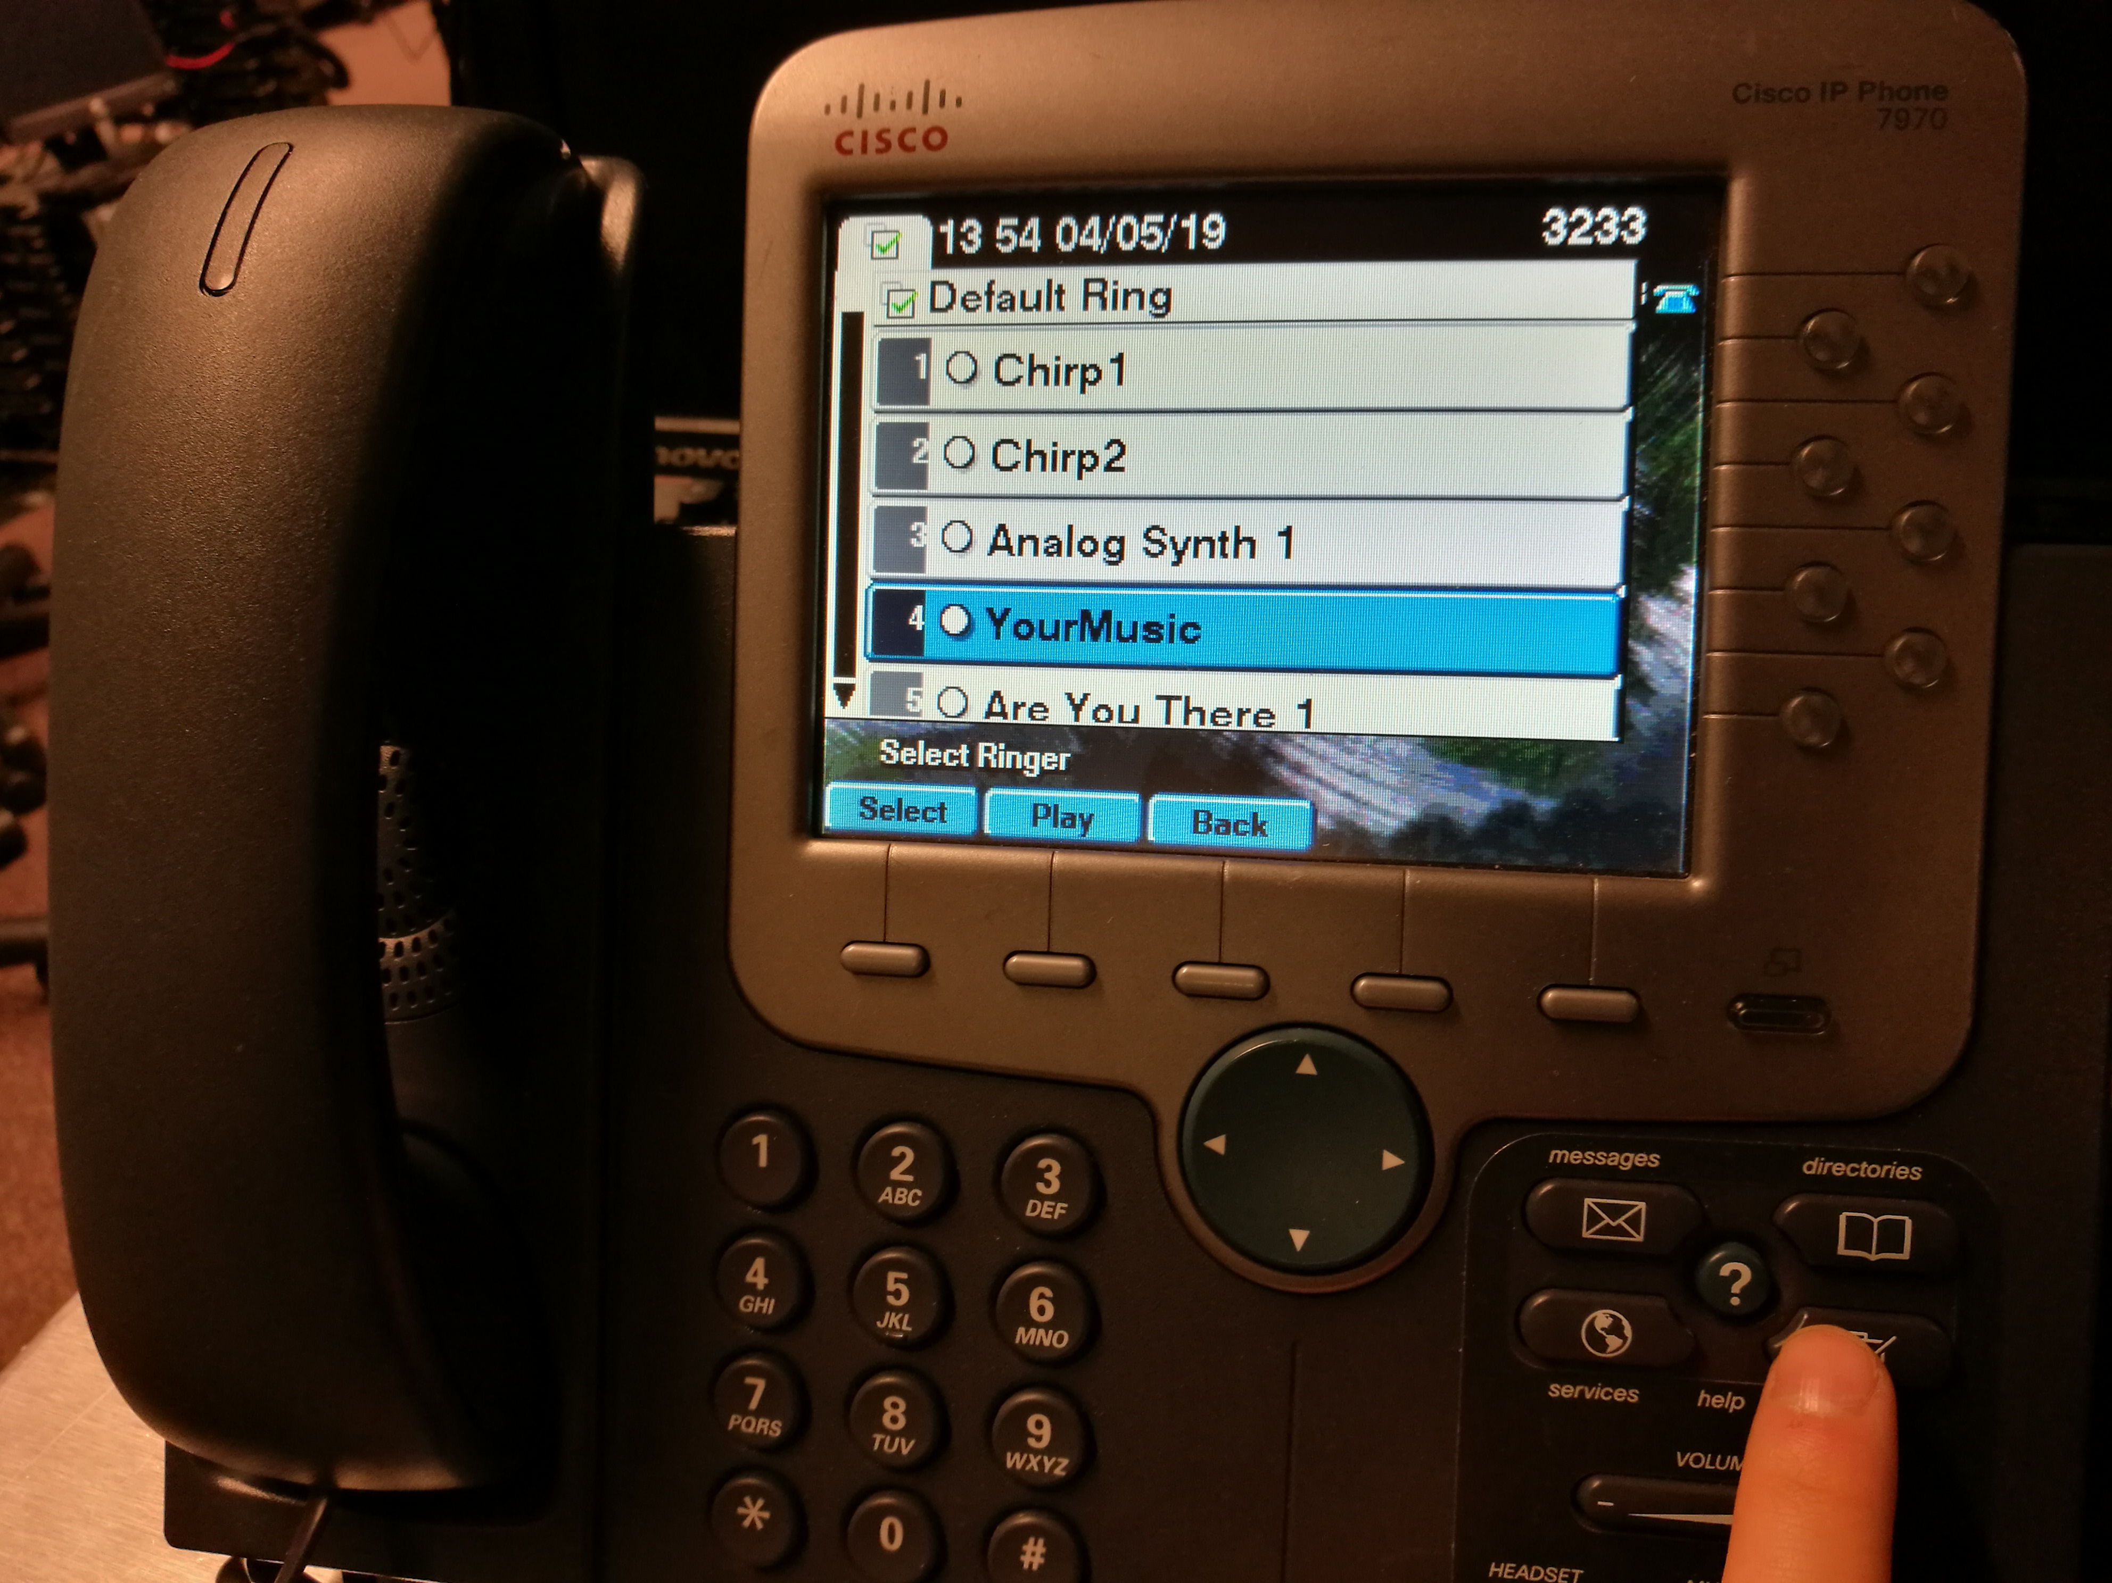

### Callout cucm configuration:

Most of Callout configuration is done on the router. On CUCM, you just need to register the Voice Gateway (router) and define the route pattern (in this case, I established that everything starts with ‘9’ is a callout).

First, go to Cisco Unified CM Administration; Device => Gateway (I have my configured gateway there). Click either “Add New” or edit the existing gateway.

#### **Register for Voice Gateway:**

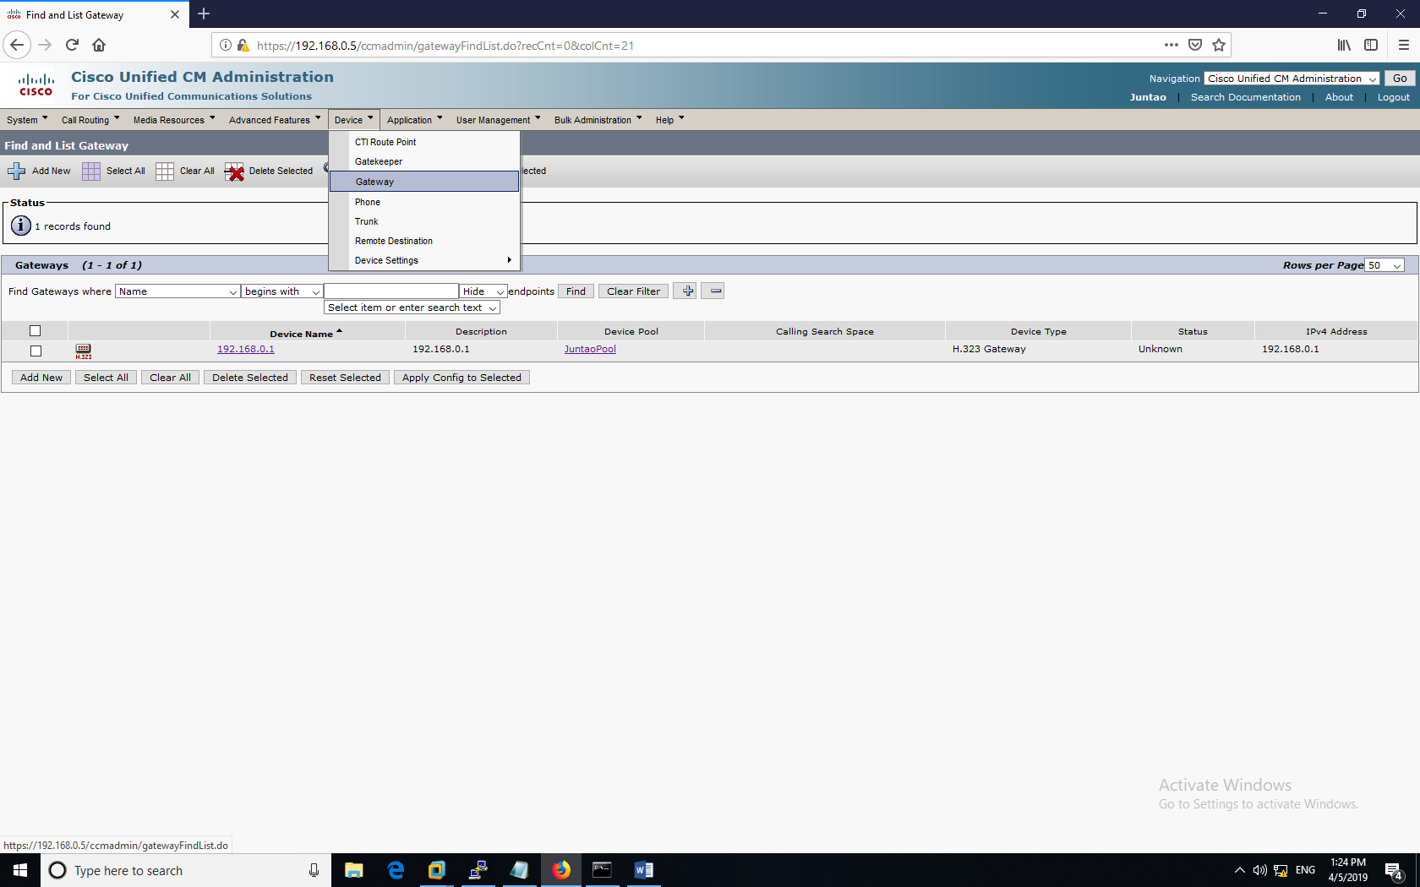

The type of device is “H.323 gateway”; the name is gateway ip address—network connected to your CUCM. Choose the right device pool and make sure the location is right.

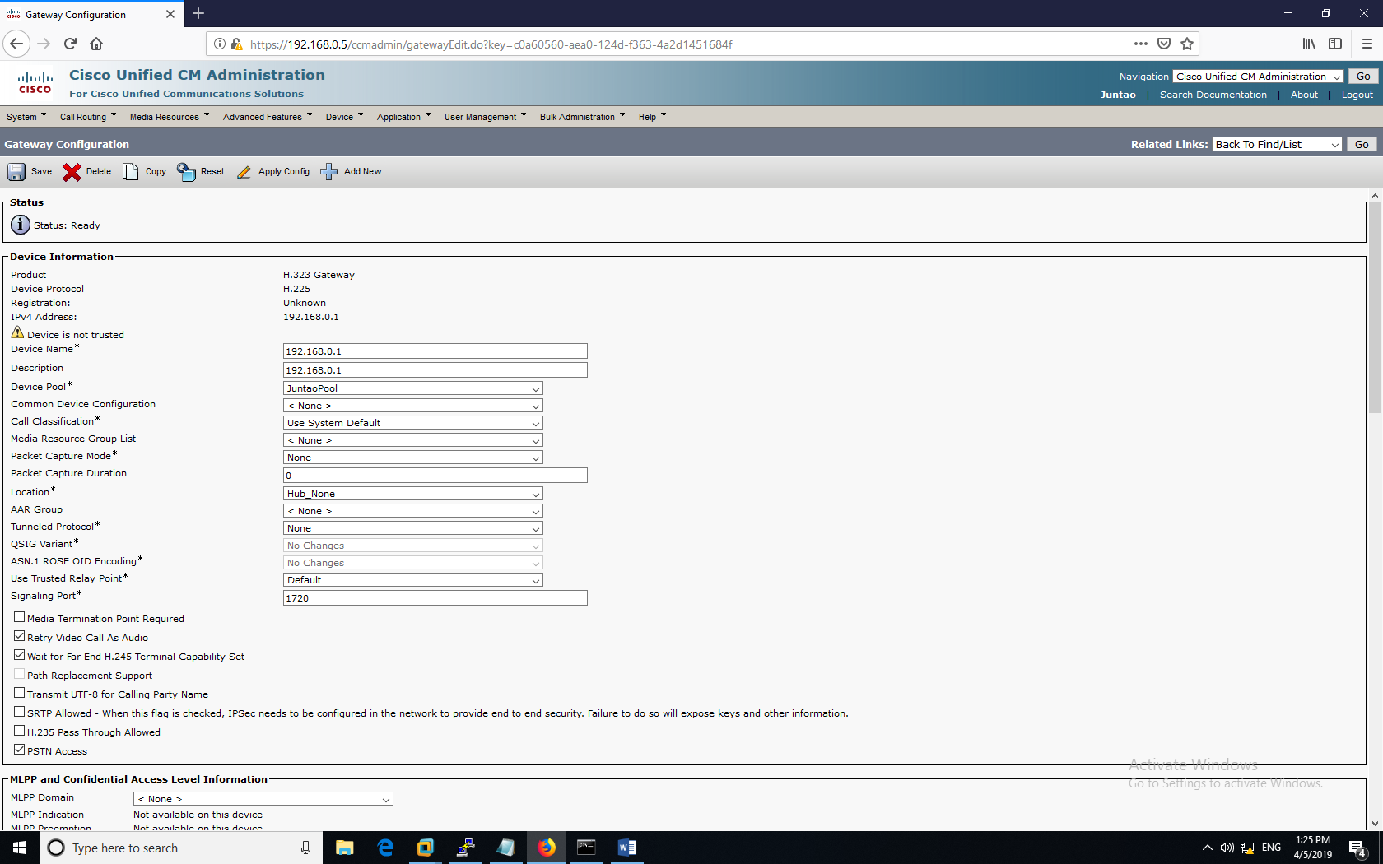

Attention: to enable call in, make sure to check “Enable Inbound PortStart”.

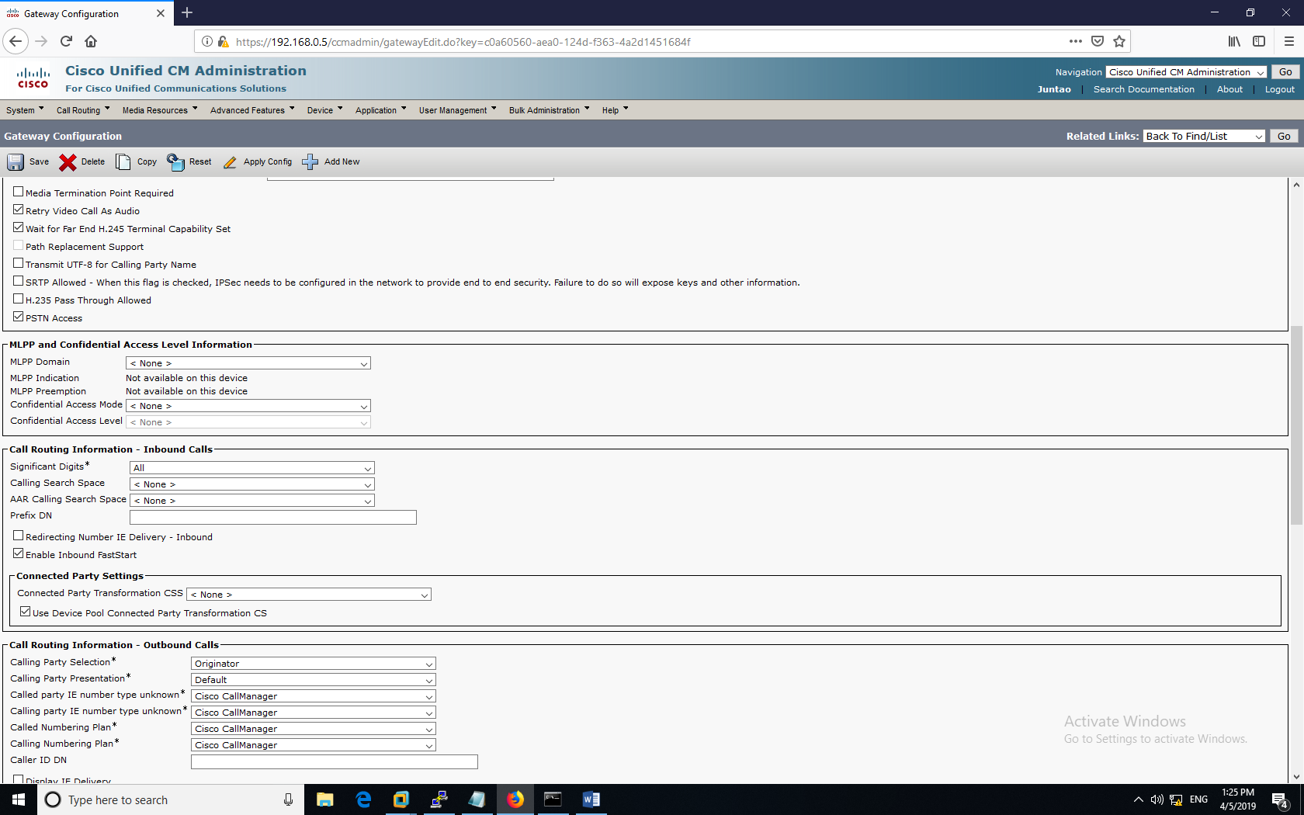

#### **Define Route Pattern:**

Go to Call Routing => Route Pattern

Add a new route pattern or edit an existing one.

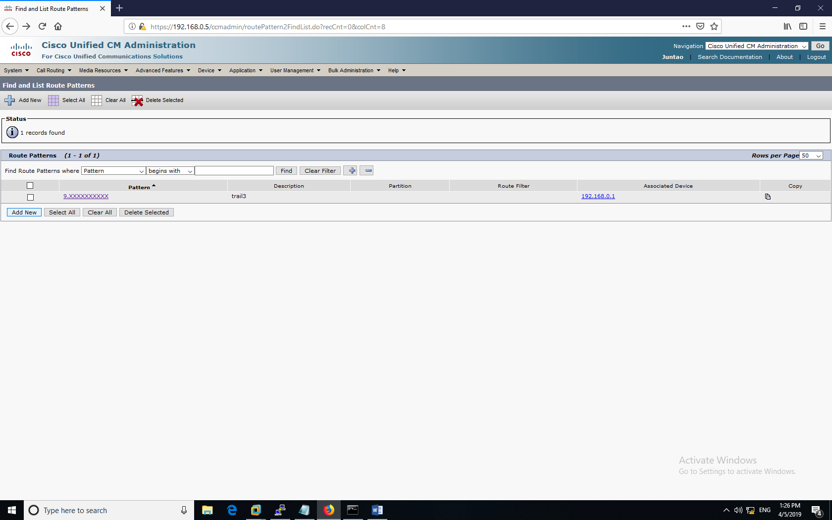

In 9.XXXXXXXXXX, “9” means all calls starting with a 9 is an outward call. 10 “X”s means that it will only forward the phone number that has ten digits (our common cell phone number). Two parts are divided by a dot.

Also, make sure to choose the right gateway (router) to route your voice traffic out.

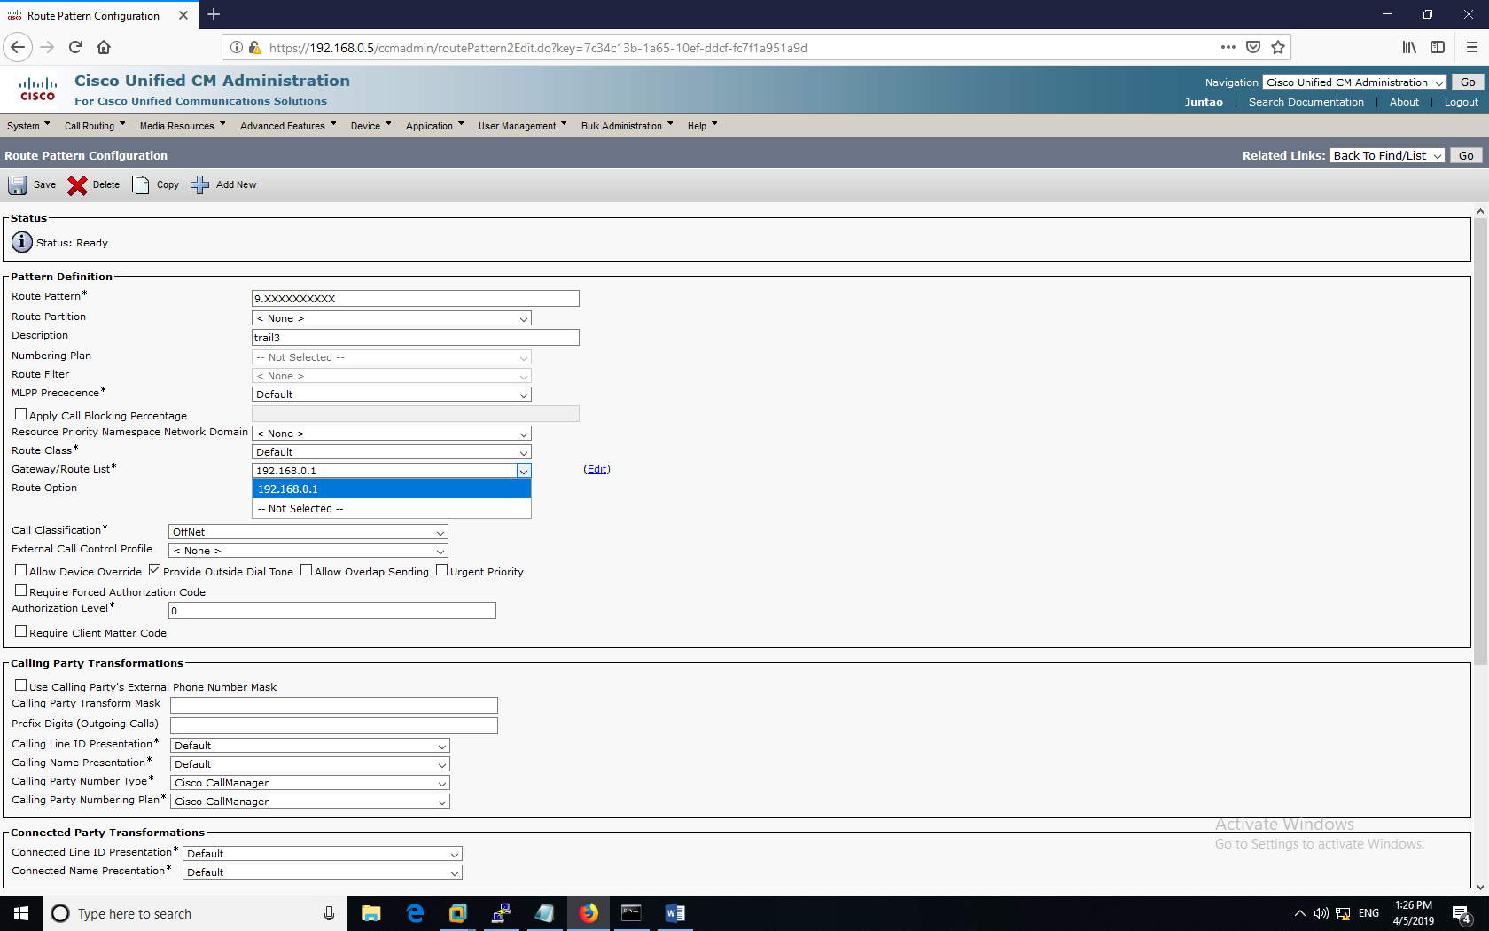

Then, your lab phone can reach out to your personal cell phone. And your cell phone can reach into your lab, too.

This are pictures of the physical phones. (206)-643-9305 is my cell number; the lab phone number is (425)-7435-3333. My phone has an international card, so it doesn’t should the lab phone number right.

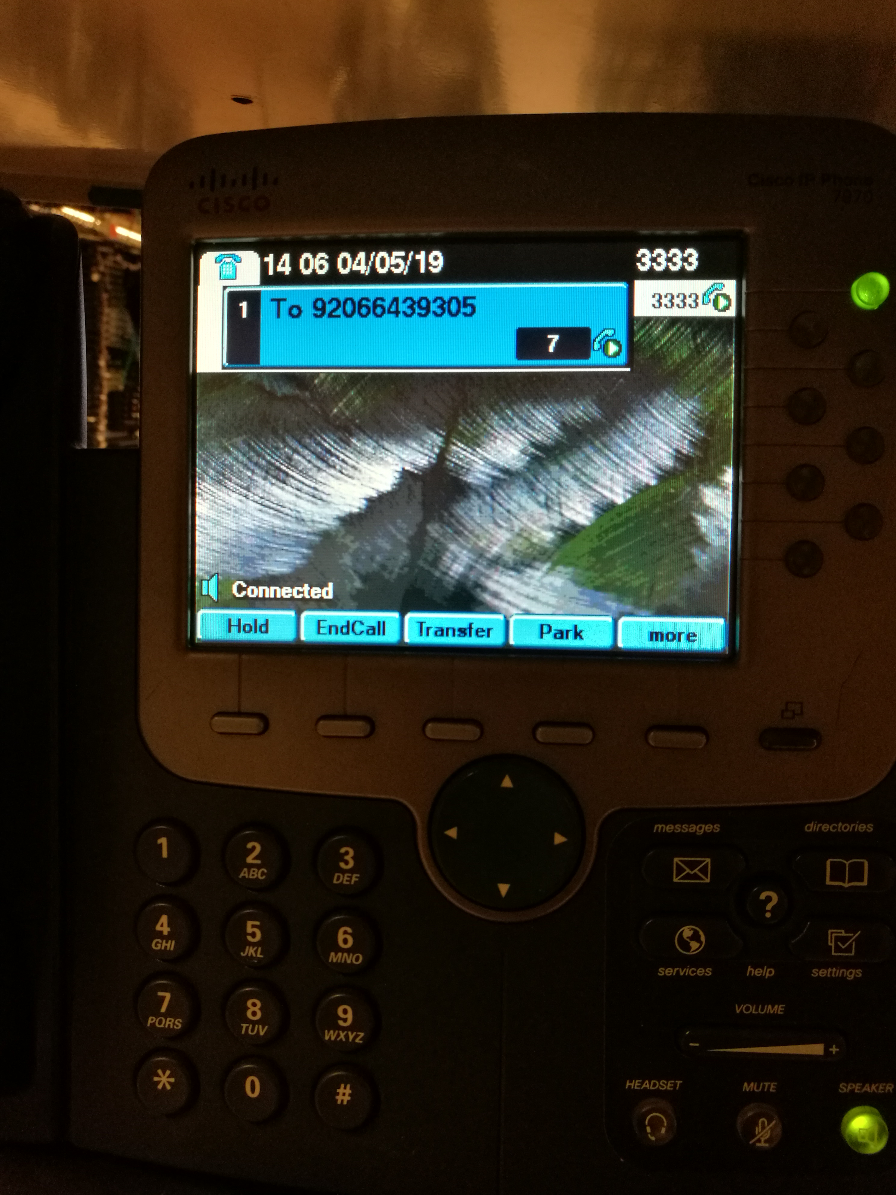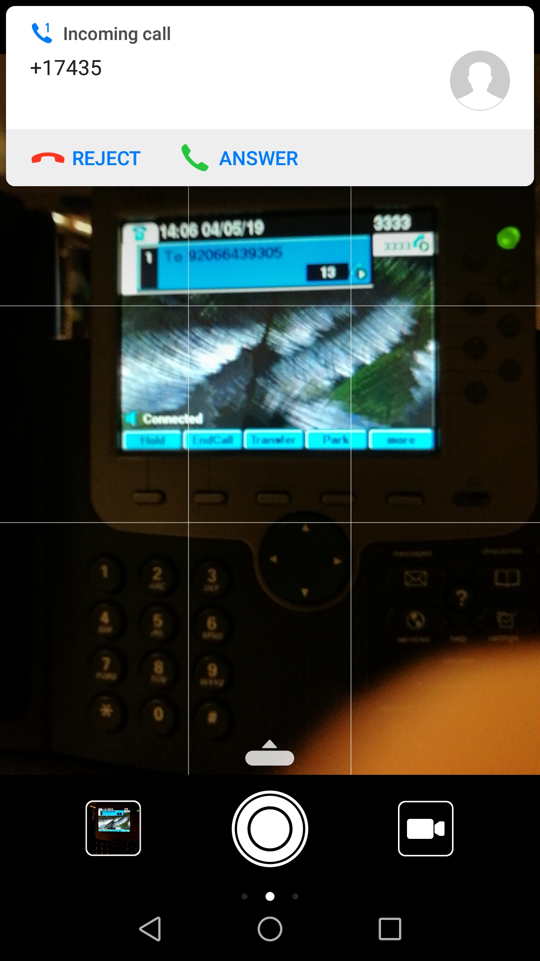

### voicemail configuration:

#### **Installing CUC (Cisco Unity Connection) server:**

Click “Create a New Virtual Machine”. CUC can run on Red Hat Enterprise Linux 5 64-bits. Unlike CUCM file, we start with an iso. Choose the “CUC-Multiple-Deployments-v1.0”.

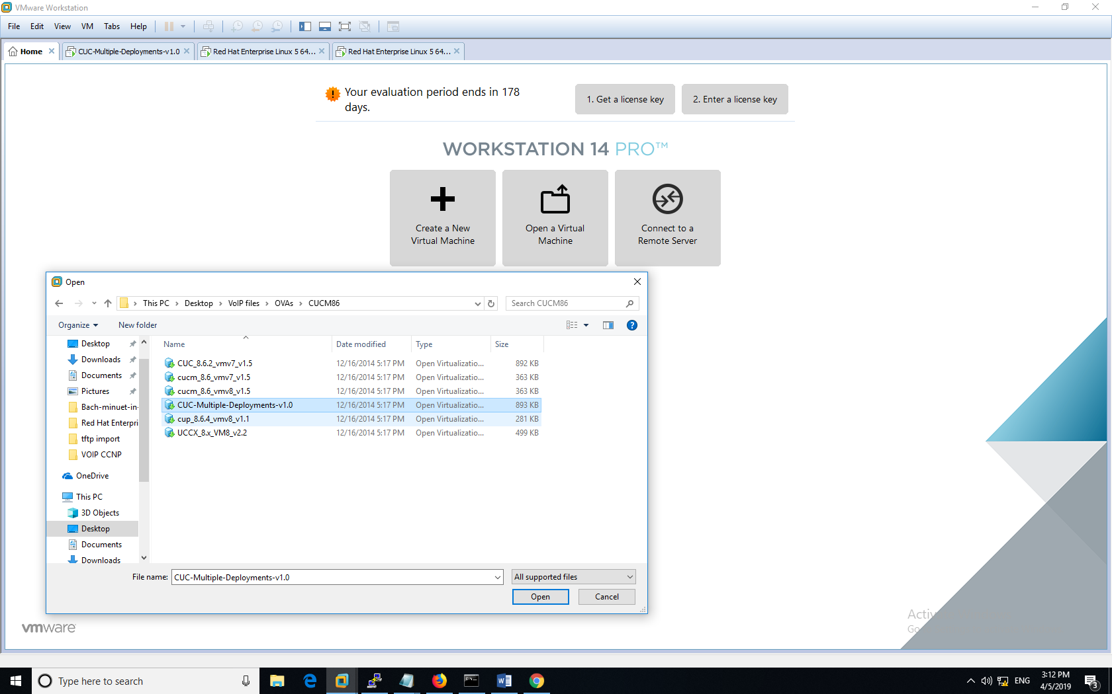

It asks users size for your CUC. I just chose the smallest one—500 users. For 500-user CUC, the minimum storage requirement is 160GB, and I gave it 4GB RAM, so it runs smoothly.

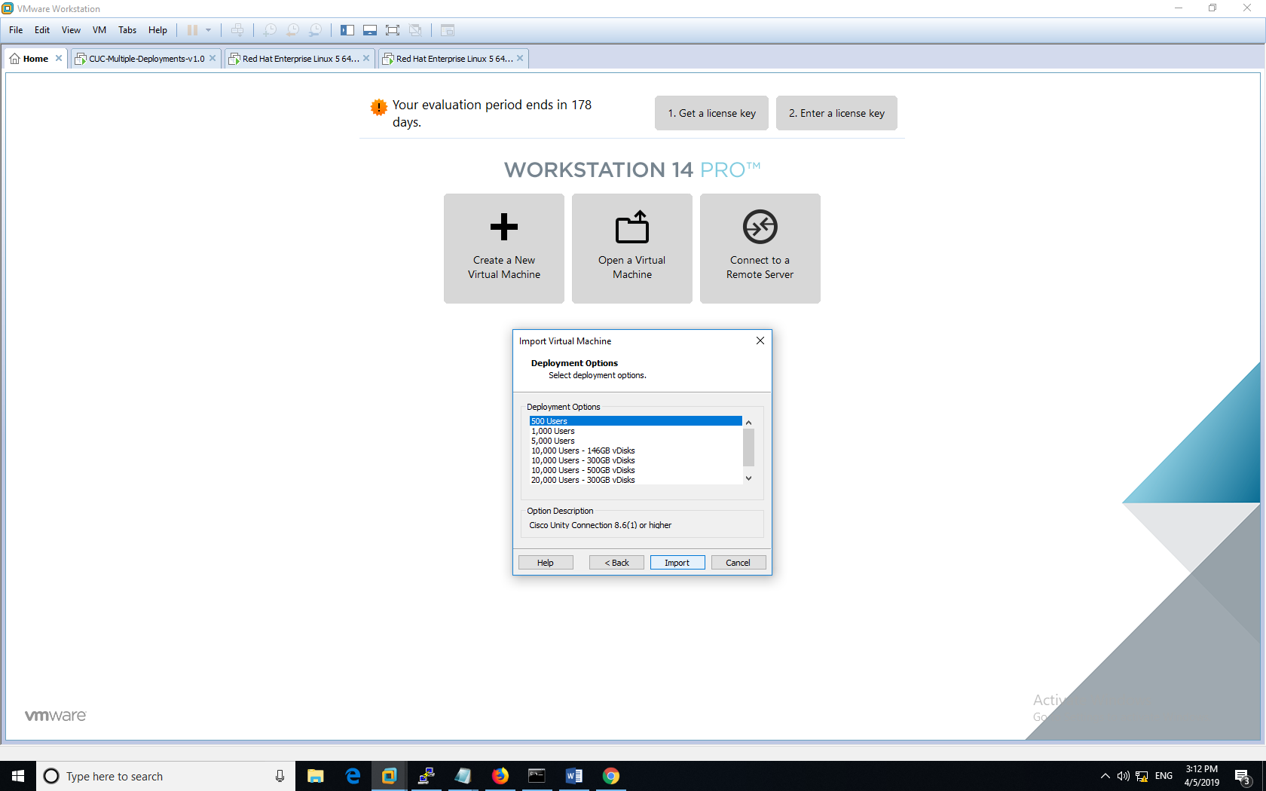

Run the Virtual Machine, but it will be stuck on CLI. Now, we need give the system an iso. image of the system to install. Find the disk ion (very small, on bottom right), and reference the bootable iso (Bottable_UCSInstall_UCOS_10.0.1.10000). Make sure to connect this virtual CD/DVD to your VM.

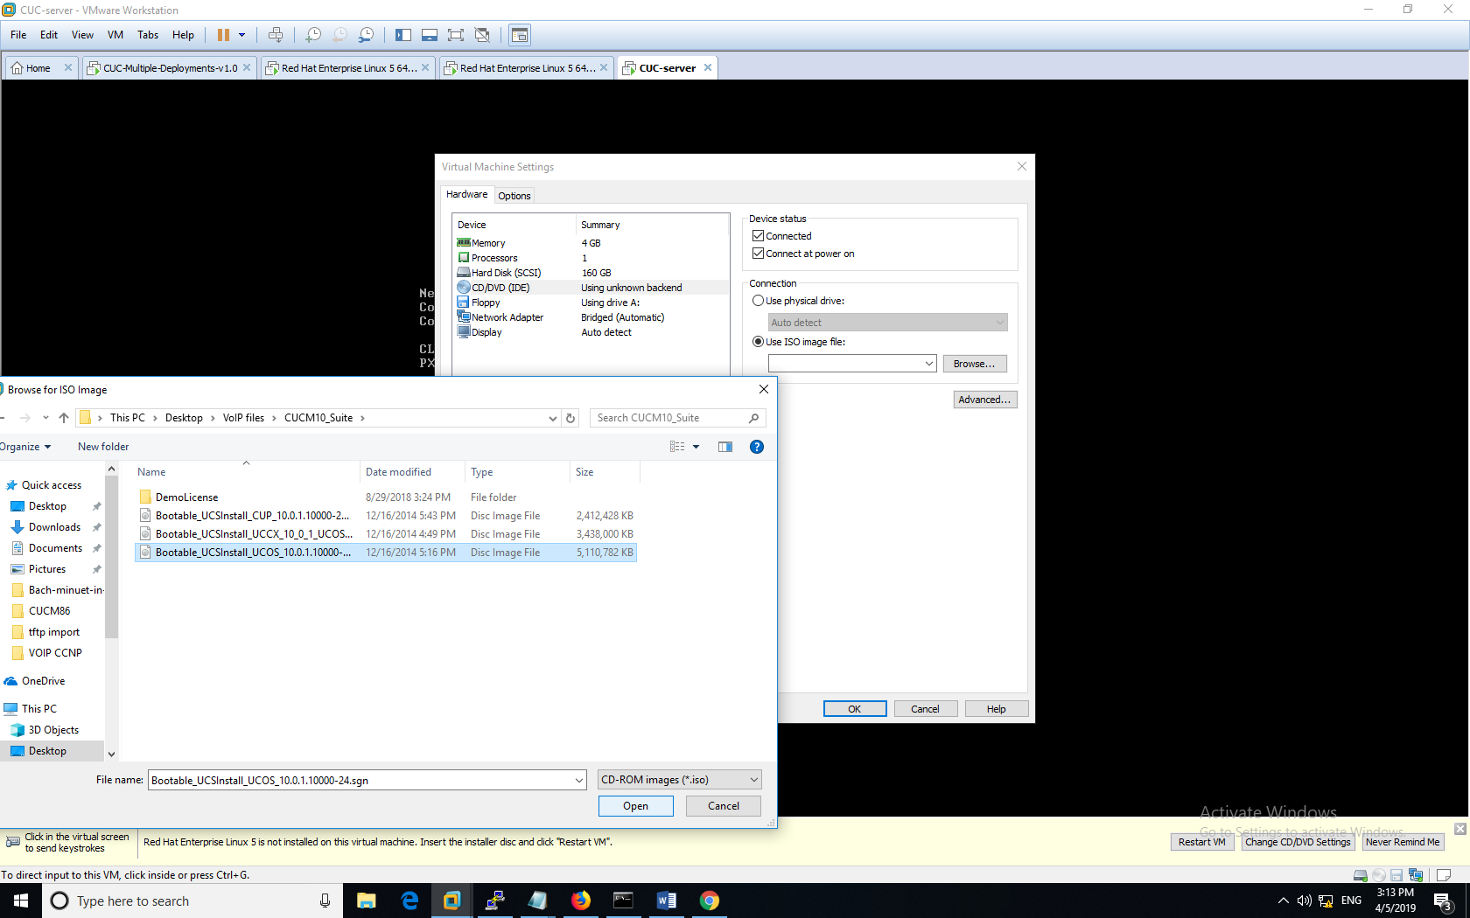

After you give VM the right reference to iso, restart the machine. This time, CUC VM will start the installation process like CUCM. You will have two choices. Choose CUC instead of CUCM. You should set its IP address static, find the NTP server as you did in CUCM.

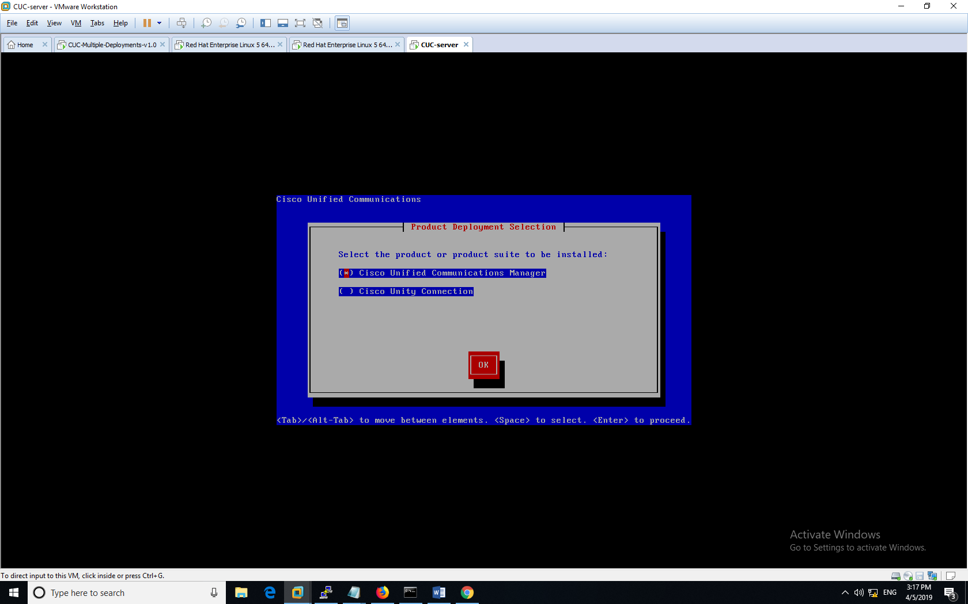

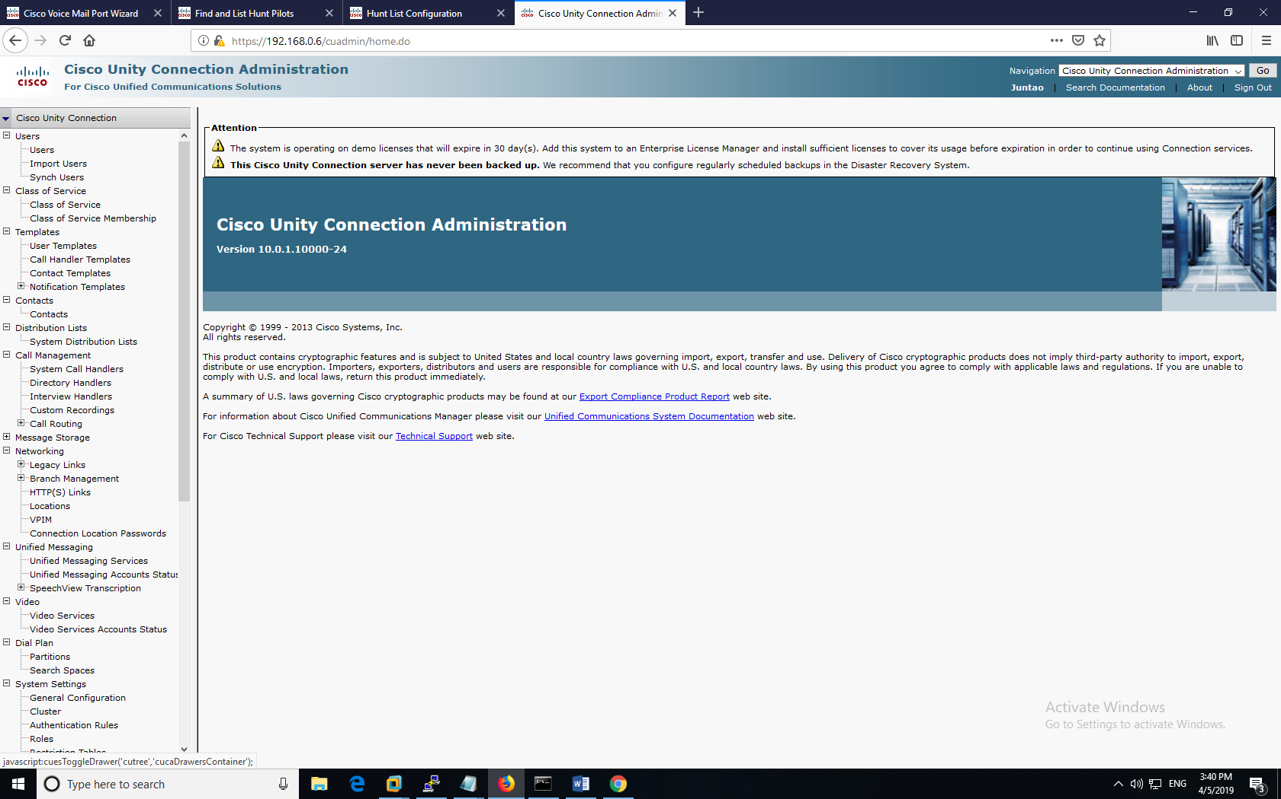

Type in the CUC IP address, and you get into a Web GUI similar to that of the CUCM.

#### **CUCM Configuration:**

Now, we have successfully set up the CUC server. But, we will wait for CUC to initialize while we do voicemail configuration in CUCM.

First, in Cisco Unified CM Administration, go to **Advanced Features => Voice Mail => Voice Mail Profile.** Add a new voice mail profile or edit an existing one. Voicemail server has a number, in this case, I set it to “9000”.

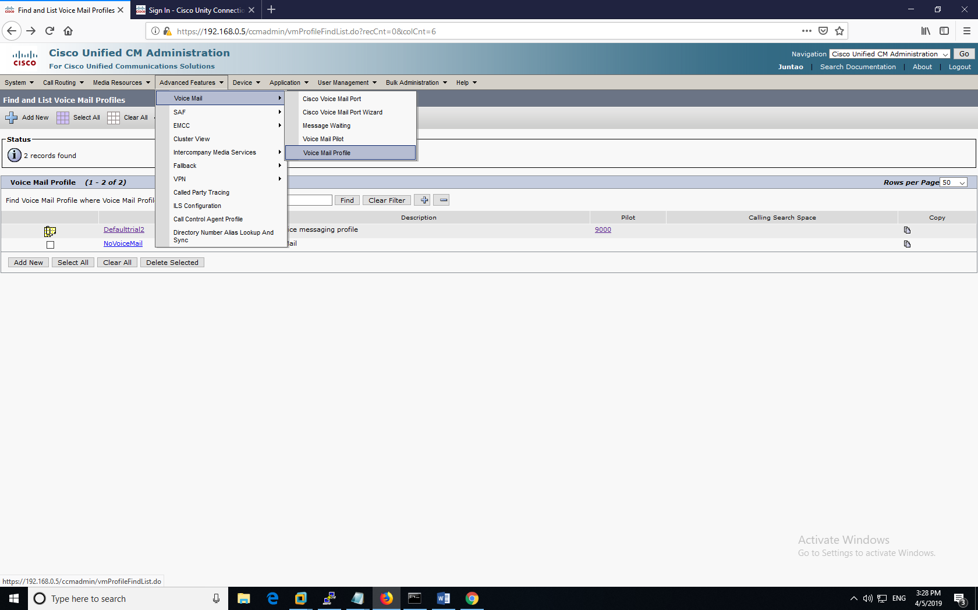

You don’t really have a lot of things to configure in Voice Mail Profile. The most important thing is to assign the voicemail server number “9000”.

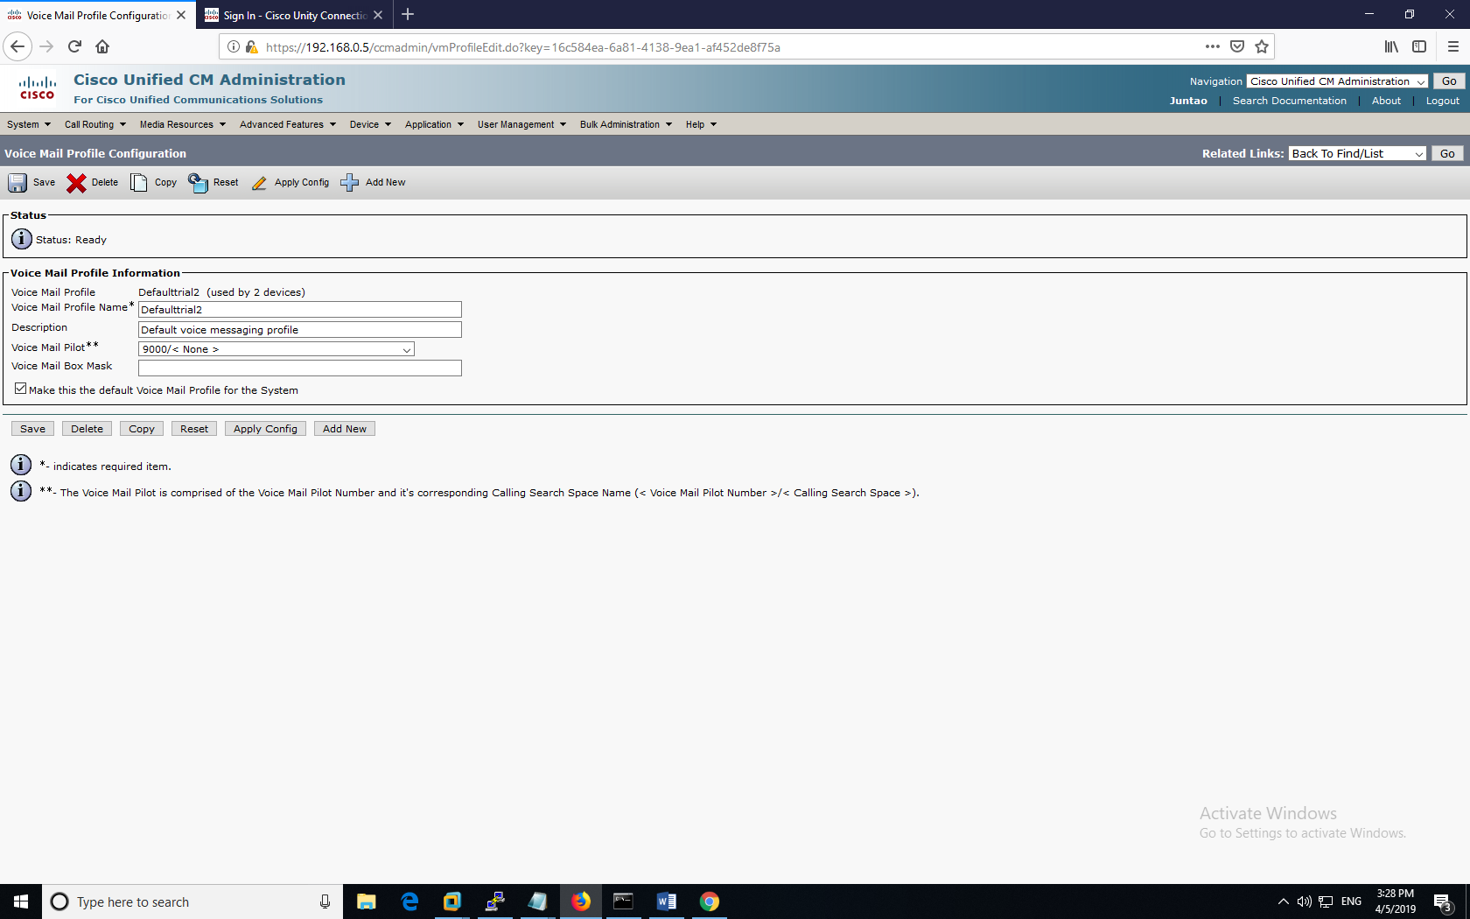

Then go to **Advanced Features => Voice Mail => Voice Mail Pilot.** In here you define the number for voicemail (I made it 9000). So, when your phone calls this number, you reach the voicemail.

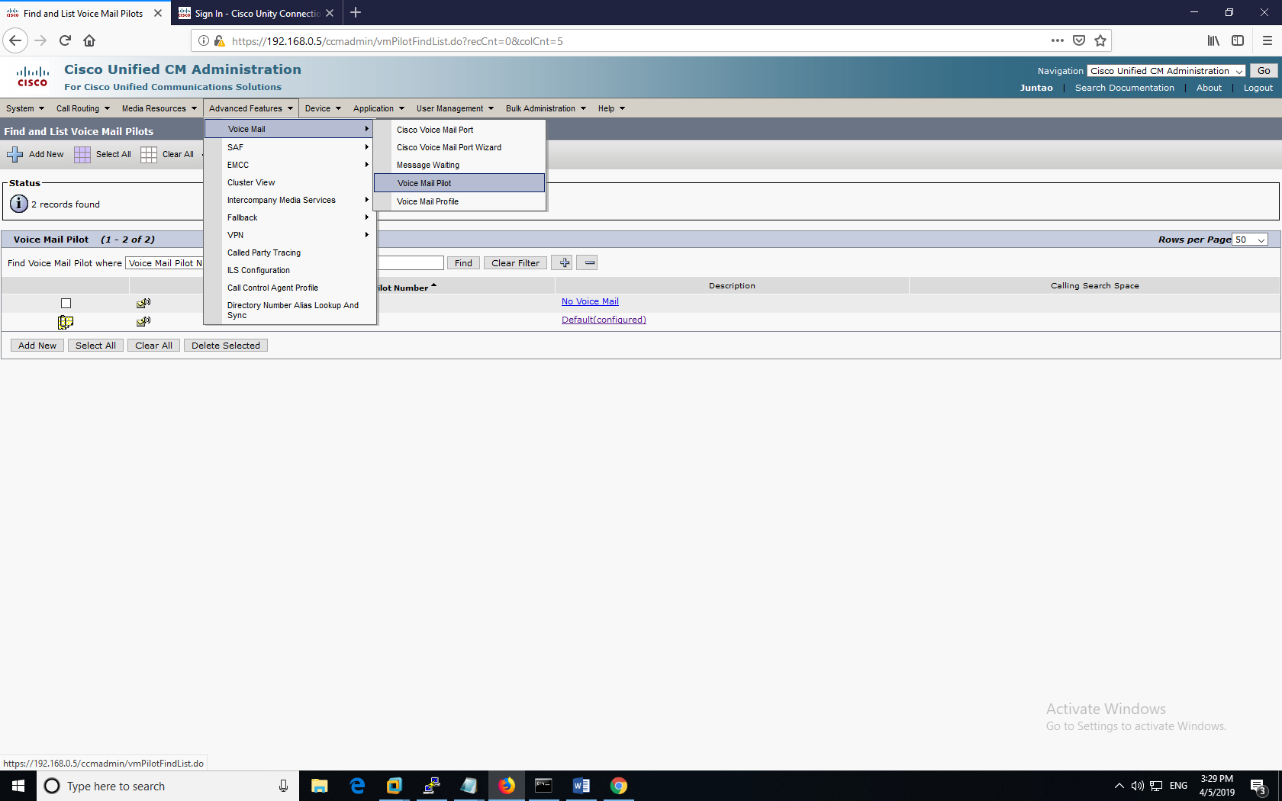

After entering “9000” make sure to make this phone the default number, which is marked by a special icon on the left.

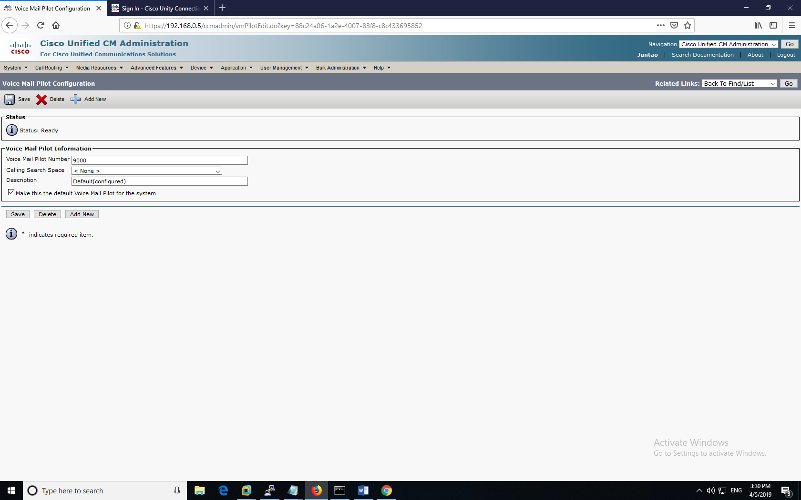

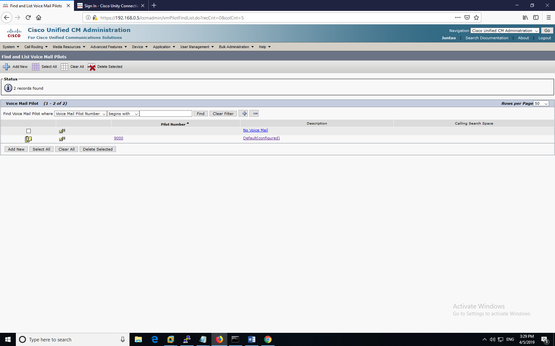

Then go to **Advanced Features => Voice Mail => Message Waiting** (not shown, it’s in the same place as Voicemail Pilot, third option). At the beginning, you should only have one directory number. You can add a new one (you need two of them, one for “on” and one for “off”). You may configure the directory number.

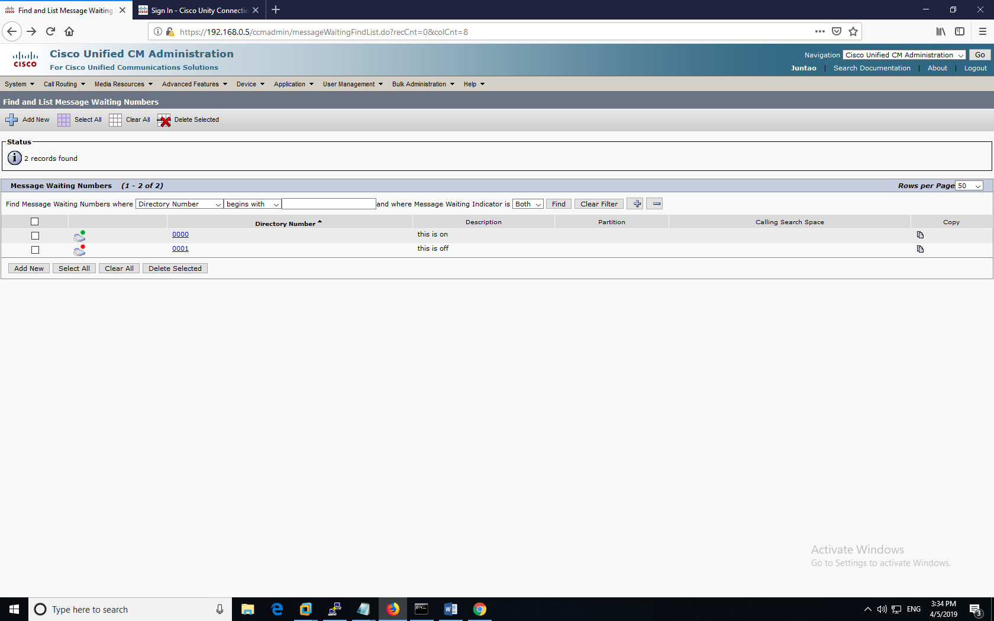

Configure the directory number to that you want (for me, I made it 0000 and 0001). There must be an “on” and an “off”. These two numbers will be referenced later in CUC.

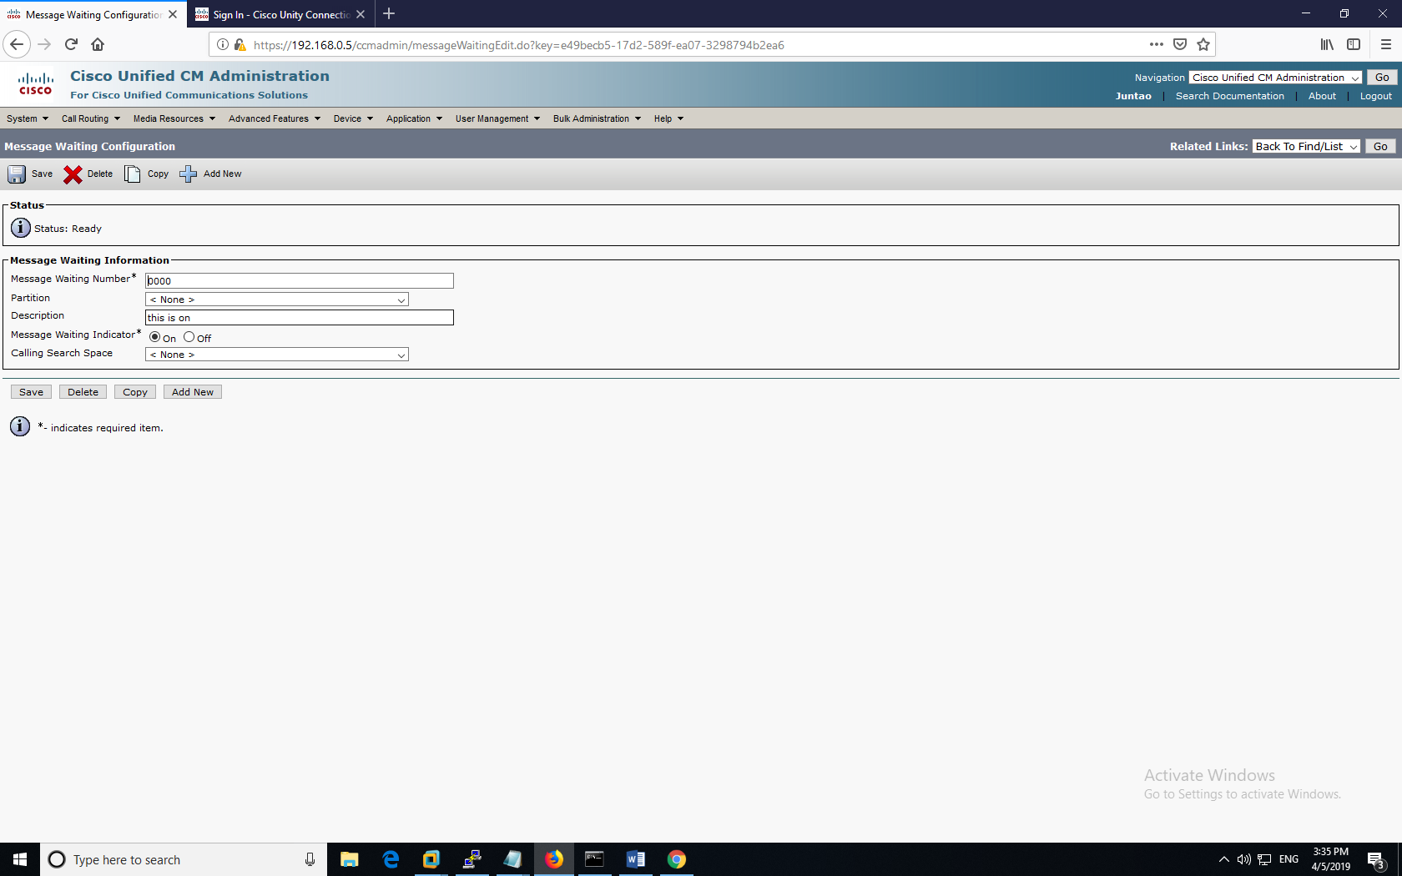

Next, go to **Advanced Features => Voice Mail => Voice Mail Pilot Port Wizard** (it’s in the same dropdown, not shown). You want to choose “Create a new Cisco Voice Mail Server and add ports to it”

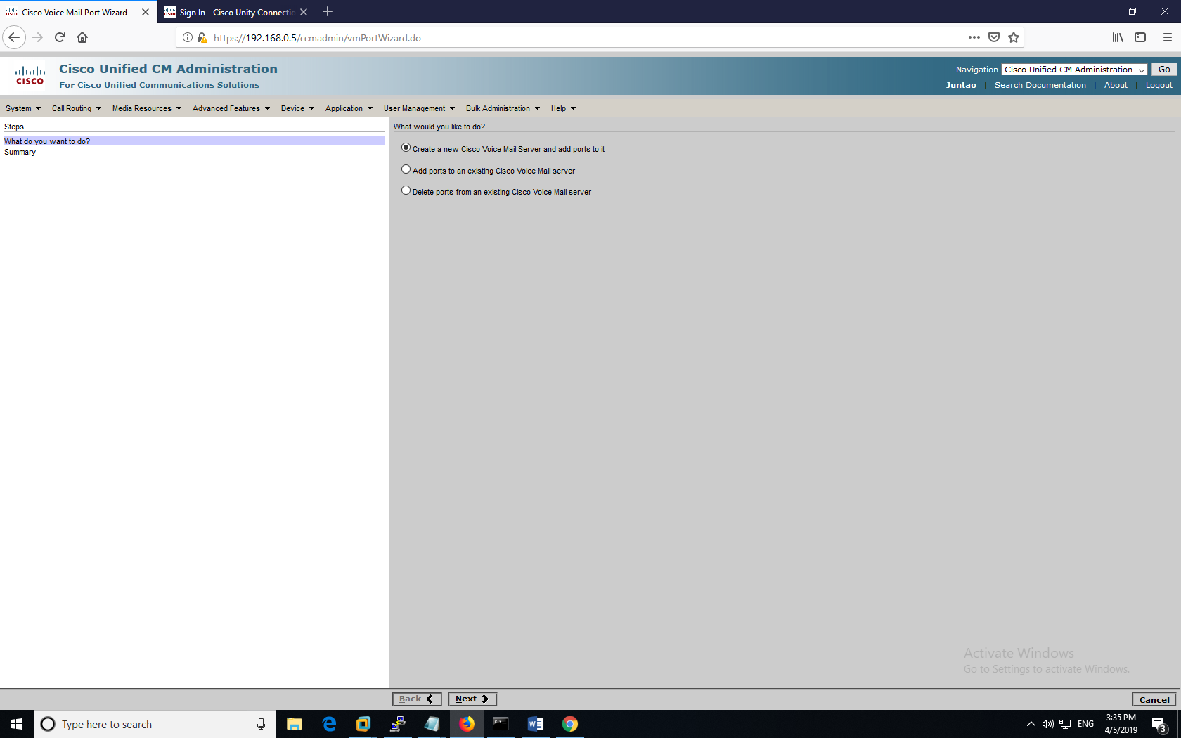

Name your server group. It must be unique in your CUCM, and it will be referenced later in CUC.

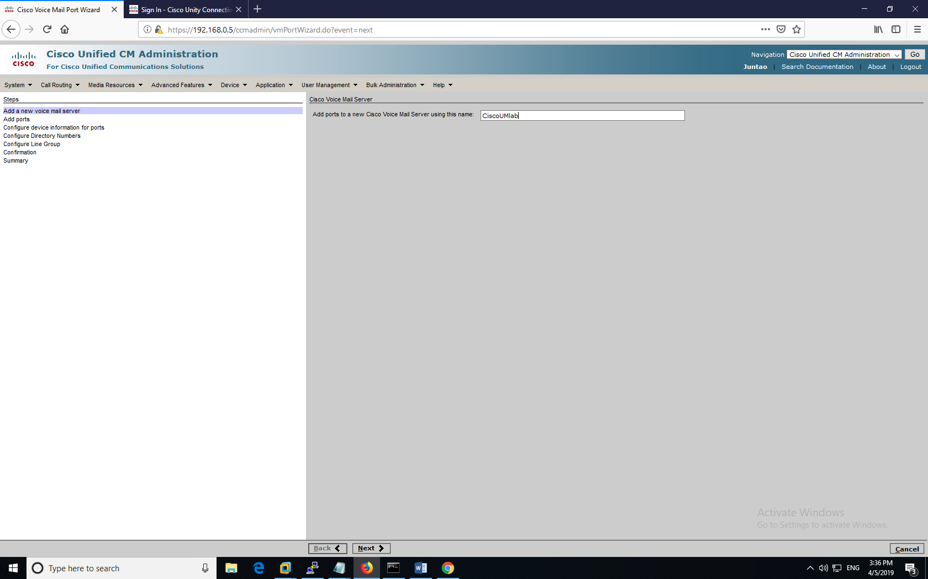

Run through the guiding wizard. I have two phones, so I add 2 ports. Device security mode use not secure mode (default). The directory numbers for voicemail are voicemail numbers assigned to your phones. They should be different from the actual phone number you assigned in part I.

Make sure that your “Line Group” is the same as your “Cisco Voice Mail Server”.

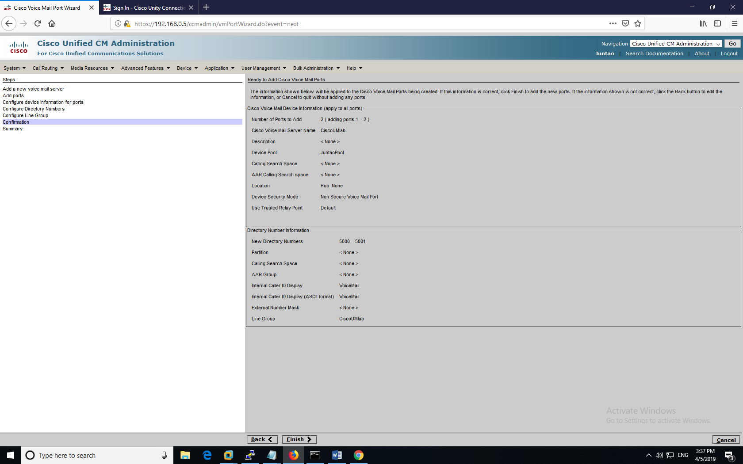

After finishing, the Voicemail Wizard will present a summary. This page is very important (I recommend opening the links in another tab). Follow the two steps written there. First, “Add this Line Group to a Hunt List”; then, “Assign this Hunt List to a Hunt Pilot”.

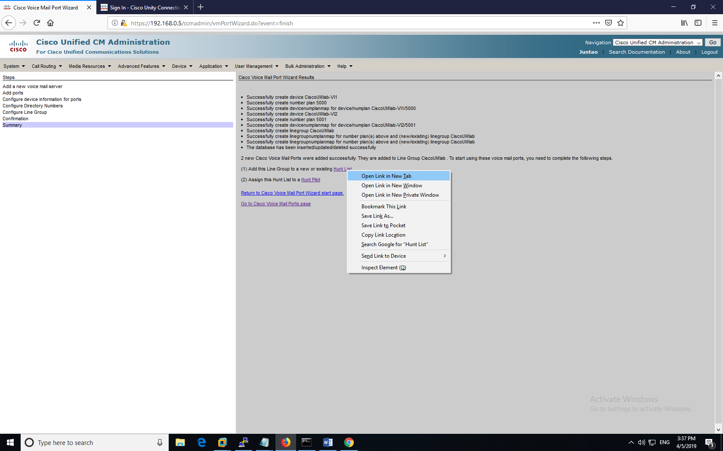

Click the first link and add a hunt list. Click “Add Line Group” and you will see your voicemail line group that you defined before. Select that group and save it.

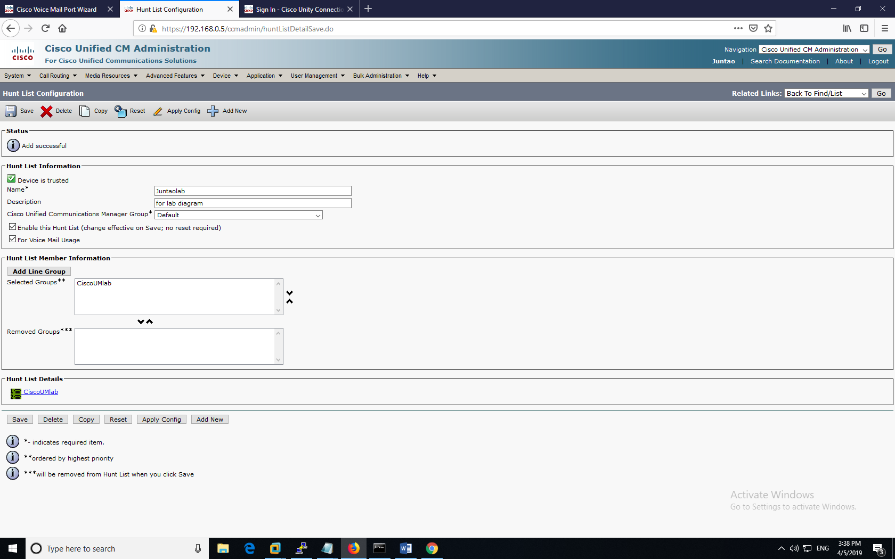

Then, go to Hunt Pilot, select the hunt list that you configured before. Also check the Hunt Pilot number.

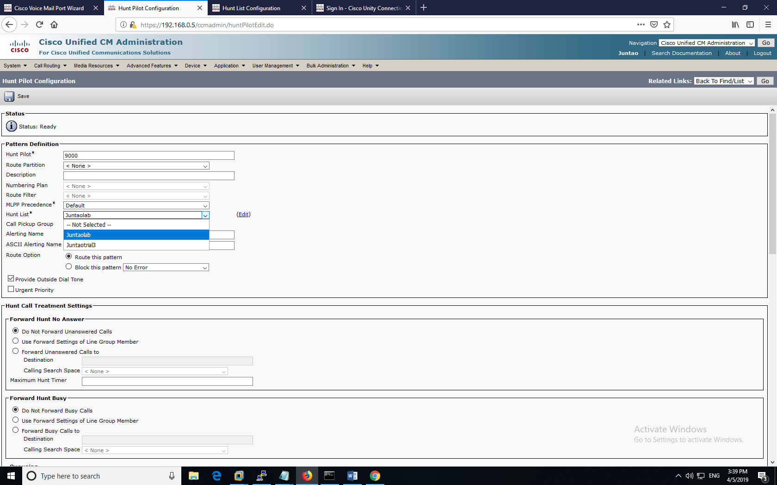

Now, go to **Advanced Features => Voice Mail => Voice Mail Port Pilot**, and check that there are two ports added. With the right voicemail directory number and Line Group. Remember the Line Group name “CiscoUMlab-VI”; it would be useful in CUC, the next step.

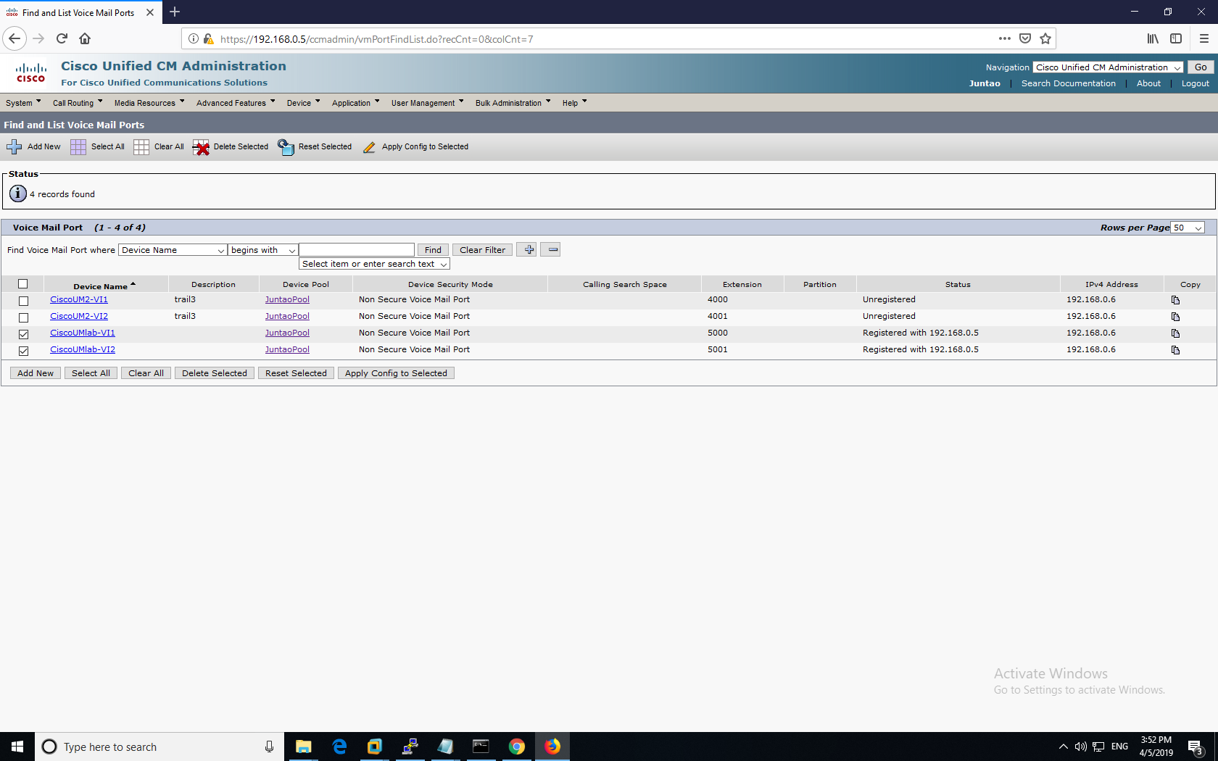

#### **CUC Configuration:**

On the CUC Web GUI, go to **Telephony Integrations => Port Group**.

Add a new group or edit the existing group. I am using SCCP phones, so my port group type is “SCCP”. Edit the displayed name (it should be “PhoneSystem-1” in context of the following screenshots). Device name prefix is the name in the previous step from CUC. MWI on and off extension must match the previous configuration in CUCM.

Also, define the CUCM server and indicates its IP address.

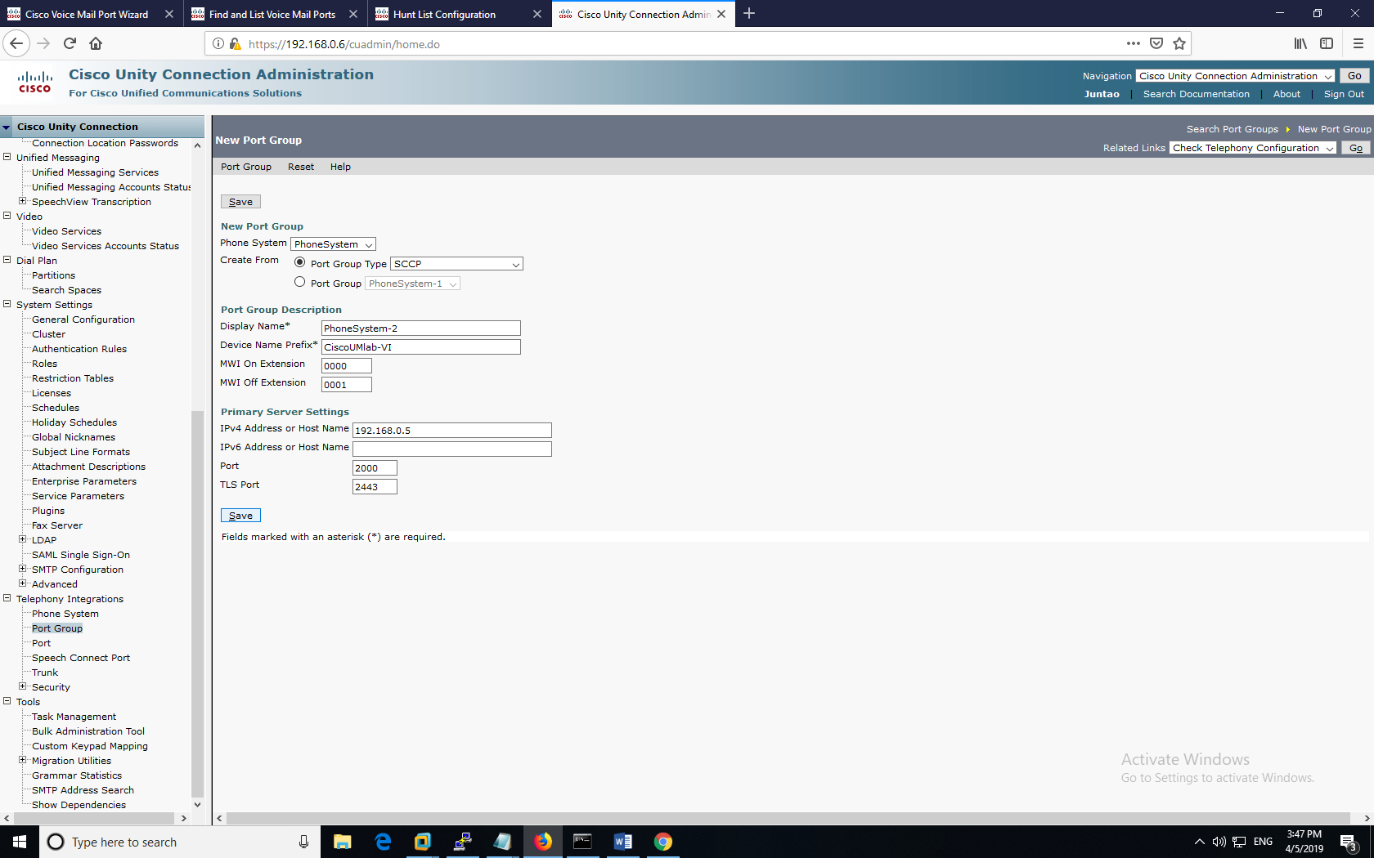

After that, go to **Telephony Integrations => Port**. Add two new ports for each of your phone. Check the server and phone systems.

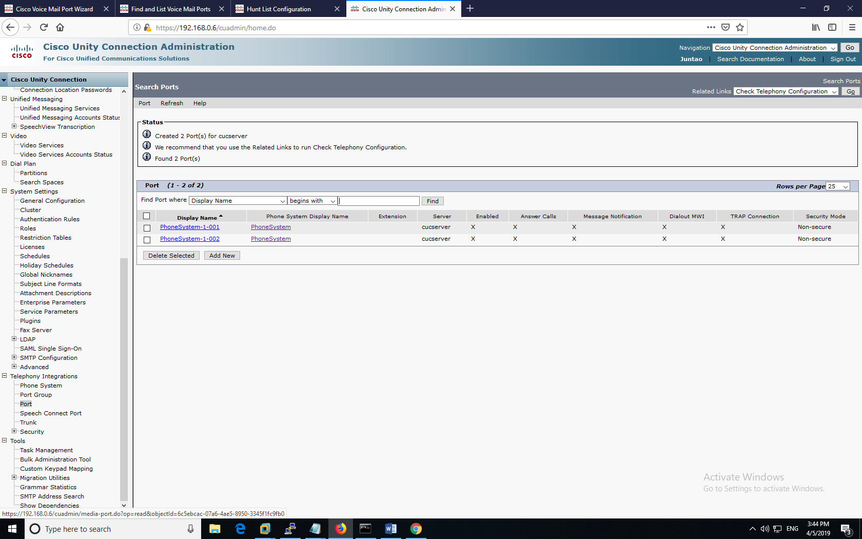

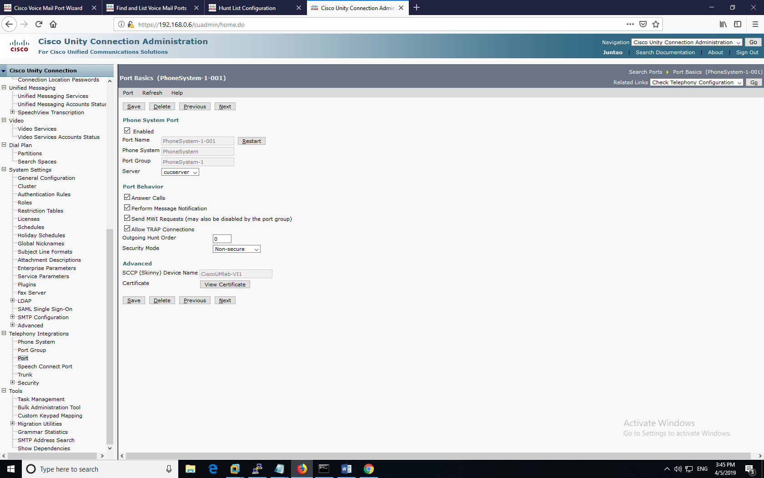

Important: you need to associate your phone directory number with the voicemail directory number. Thus, you need to define a voicemail user for each phone.

In the CUC GUI, go to **Users => Users**, and add users.

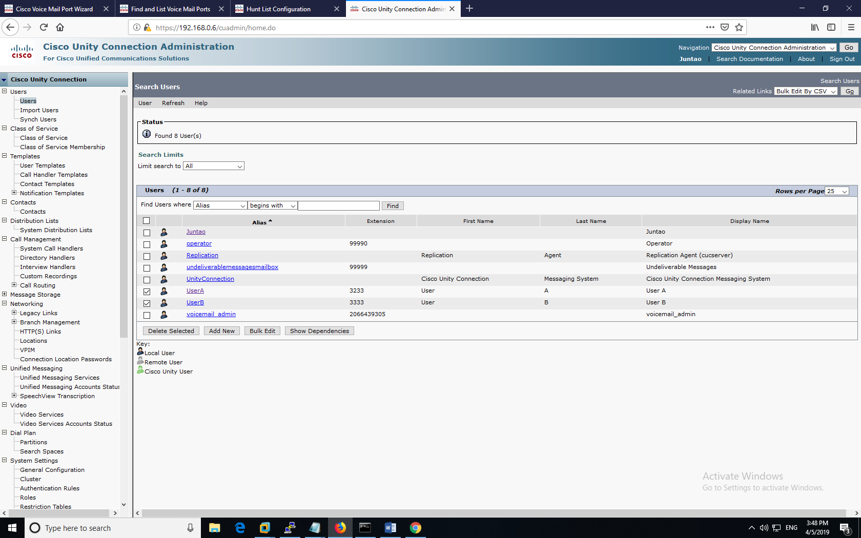

After entering the phone extension number. CUC server will automatically associate it with a voicemail port.

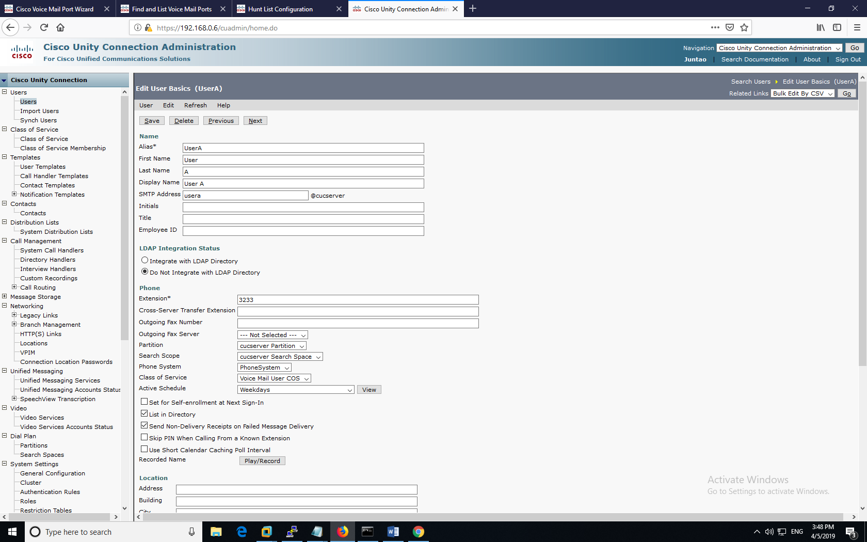

## Problems encountered

**Cisco Phones Can’t Register with CUCM:**

Cisco Phones usually have problems when they are migrated into different networks. For example, the people from last period have different IP address scheme and different CUCM address. And that prevents my phones from registering with CUCM.

Solution is to factory reset the phone. Keep pressing the “#” button. Power cycle the phone by plugging and unplugging the ethernet power. The phone will ask for reset sequence if you keep pressing “#”. Then press “123456789*0#” to factory reset.

**Plugging PTSN Line into a Switch:**

The PTSN line into the router (voice gateway) is smaller than the Ethernet line. However, the line connecting outside world is an Ethernet-looking line. So, I thought it can also be transmitted in a switch. But, the PTSN line is analog not digital; though it looks like an Ethernet, it doesn’t go through the switch.

The right way is to convert the Ethernet line into a smaller, voice-specific line; then plug it into the voice port of the voice gateway.

**Getting the Router Configuration Right for Callout:**

The hardest part for callout is getting the router configuration right. The command that I was missing was:

**mgcp call-agent 192.168.0.5 service-type mgcp version 0.1**

And it’s critical in defining the CUCM server.

**CUC Not Installing:**

If you use the incorrect procedures to attempt installing CUC, such as using the CUC multiple deployment to install it. You might run the machine but only CUCM installation will show up.

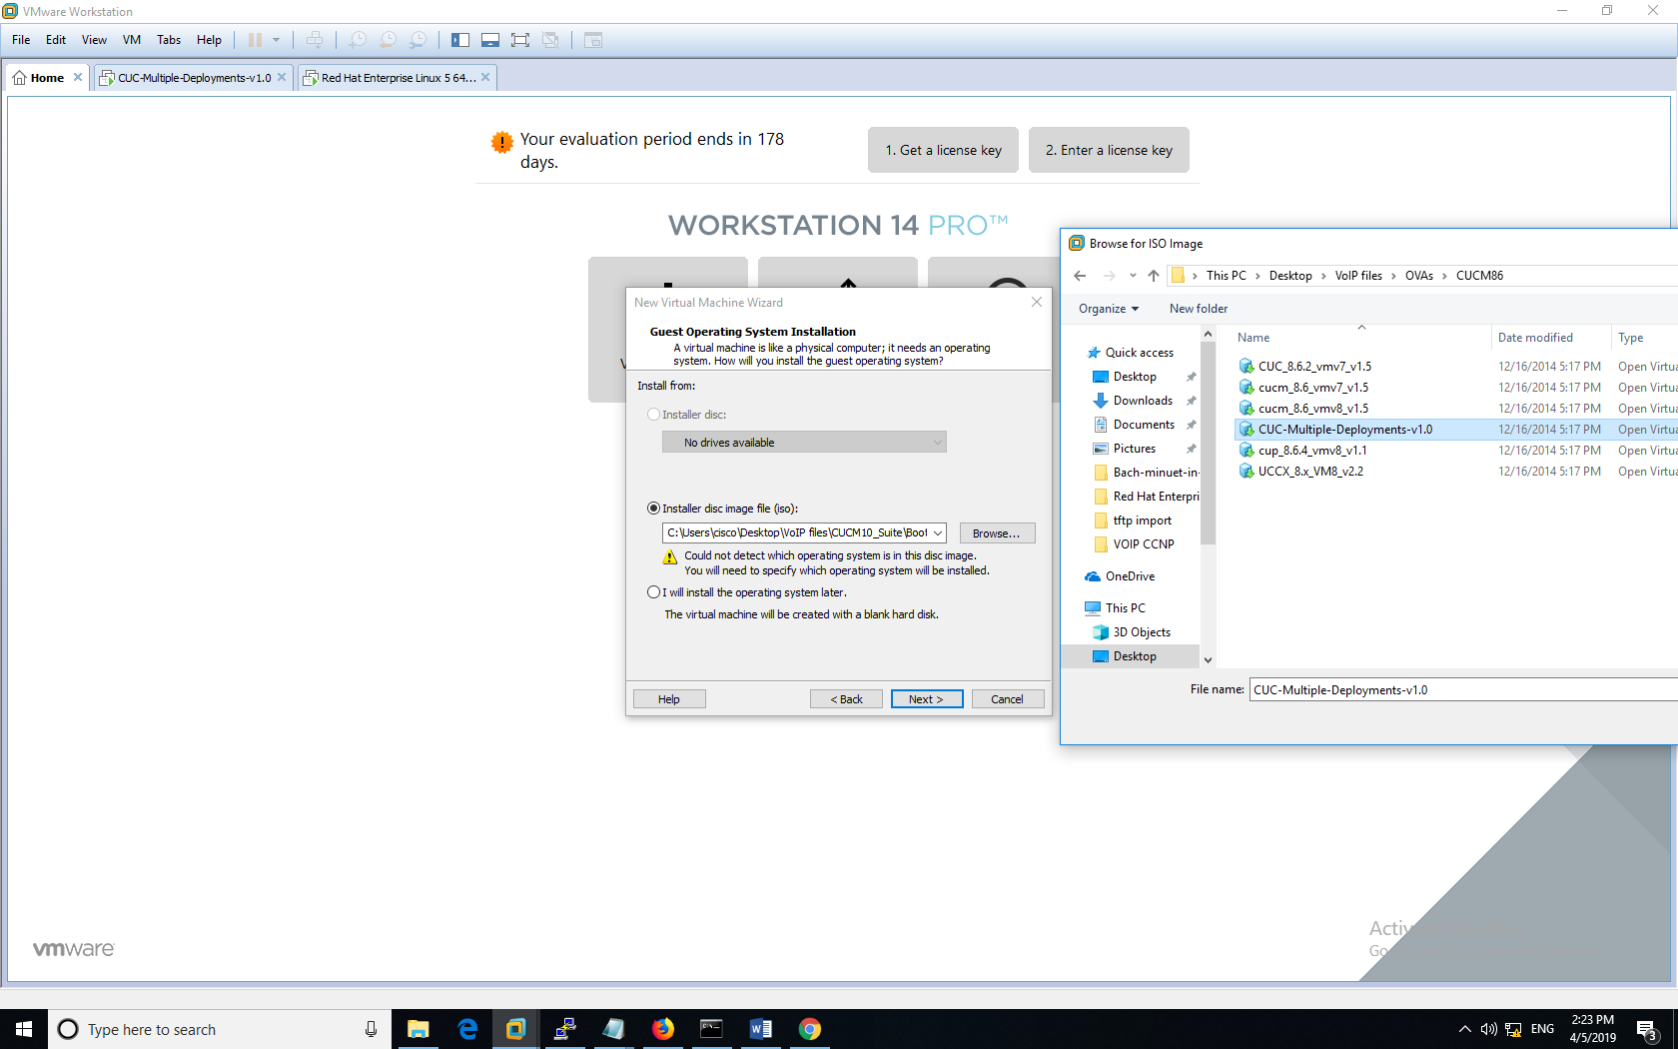

Problem: the screen shows that a CUC installation, but you can only install the CUCM (Cisco Unity Connection not supported on current hardware).

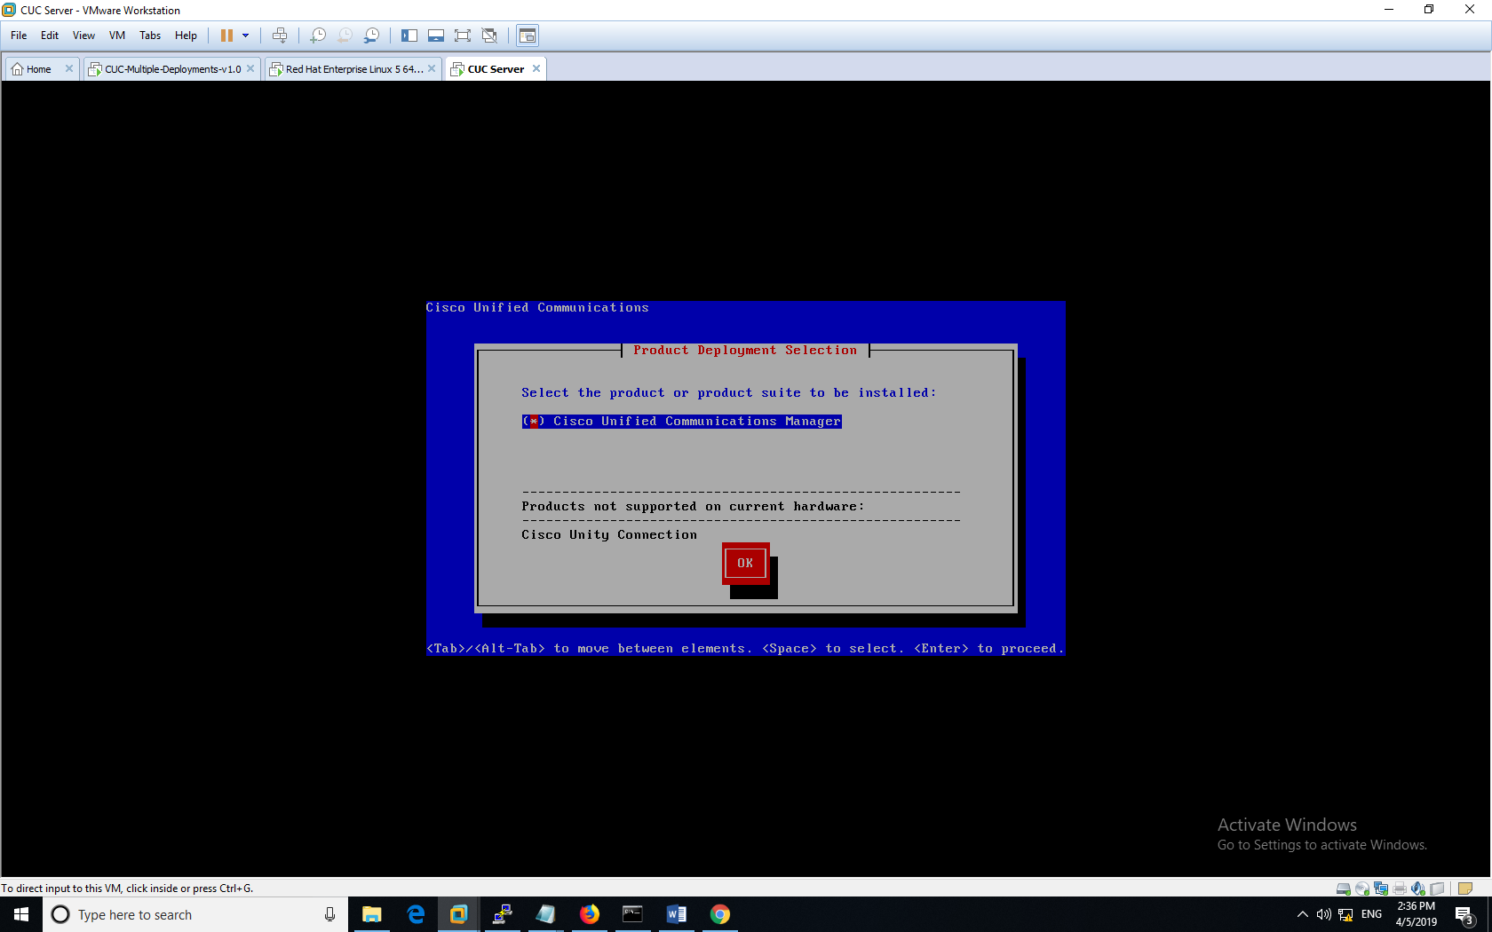

**Phone Can’t Get Voicemail:**

This is a rather complex issue. Your first possibility is that CUC is not registered with CUCM. To Check it, exit CUC and go back to CUCM, go to **Advanced Features => Voice Mail => Cisco Voice Mail Port.** Check that your Voice Mail port is registered with CUC. Check your Extension number, CUC address and Line Group names. You should see your CUC IP (we never put in CUC’s IP in CUCM, but we have put in CUCM’s IP in CUC).



**Not Sure About the Direction to Go:**

The biggest problem is probably I didn’t know the direction to go. And I’ve explored a lot in this lab. There were a lot of trials and errors.

## Summary

In this lab, I configured VOIP Ringtone customization, Music on Hold, Call in & out, and Voicemail. I used Audacity to convert music into the format that CUCM use. I used TFTP servers to get/upload files from CUCM. I also configured the voice gateway to route local voice traffic to the outer world. I installed CUC server to work with CUCM to configure CUCM. Besides these specific knowledge I learned, this style of self-learning enable me to efficiently solve other problems and do new projects in the future.